JavaScript: Advanced Concepts

# JavaScript Foundation

## JavaScript Engine

1. JS is a single threaded language.
2. It is an interpreted language.

A JS Engine helps the computer understand a JS file by translating it into machine code.



There are various JS engines available, example, V8, Chakra, Chakran, etc.

Google’s V8 enables JS to run fast. It was released in 2008.

### How JS Engine works?

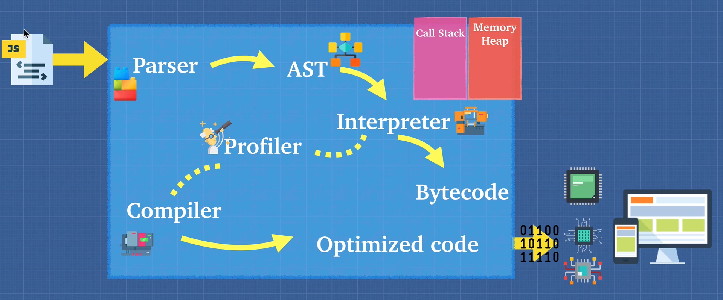

1. The first step is to do a **lexical analysis** of the JS code. This is done by a **parser** which tokenize the code.
2. Then an **AST (Abstract Syntax Tree)** is formed from the tokens.
3. Then an interpreter spits out byte code. This process is called **ignition**.
4. At the same time, a **Profiler** checks for places where the code can be optimized. Wherever, it finds such a code it passes it to the compiler to optimize that code. Example, a for loop.
5. Now the compiler replaces the optimized code in the byte code. The output, byte code + optimized code = machine code that is dumped out.

***JavaScript can thus be an interpreted language or compiled language or both depending on the engine.***

**NOTE: A JS Engine should conform to ECMAScript standard.** [List of ECMAScript engines - Wikipedia](https://en.wikipedia.org/wiki/List_of_ECMAScript_engines)

## Interpreter & Compiler

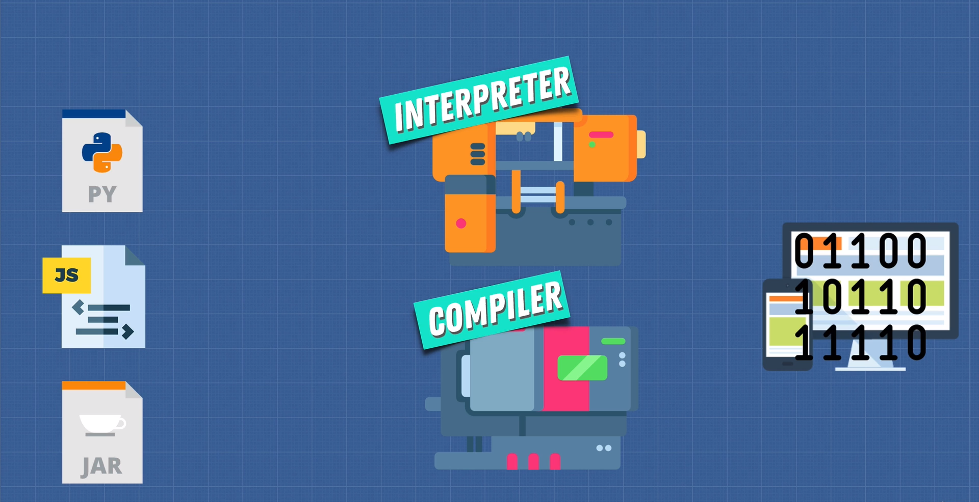

### Interpreter

* Reads file line by line

### Compiler

* Works ahead of time.
* Compiles down at beginning into machine code.
* However, at the end, the machine code is interpreted by the CPU

### Pros & Cons

* Interpreter starts up quickly and is suited for JS as the browsers need to work fast.
* Startup is slow in a compiler but it runs faster at runtime because the entire code is in machine code, i.e., compiler does optimization.

Taking the pros of both interpreter and compiler, a new compiler was developed called the **JIT Compiler**. V8 uses JIT Compiler.

## Babel & TypeScript

Have you heard of Babel or TypeScript? They are heavily used in the Javascript ecosystem and you should now have a good idea of what they are:  
  
[Babel](https://babeljs.io/) is a JavaScript compiler that takes your modern JS code and returns  browser compatible JS (older JS code).  
[Typescript](https://www.typescriptlang.org/) is a superset of JavaScript that compiles down to Javascript.  
  
Both of these do exactly what compilers do: Take one language and convert into a different one!

## WebAssembly

It is a standard for compiling the JS code for browsers. This can remove the need for a JS Engine as there will be a standard just like .exe files.

## Call Stack and Memory Heap

### Call Stack

It is a register where the instructions of the program are stored. It’s a LIFO data structure. Since JS has a single call stack, i.e., V8, it is a single threaded language. It also makes JS synchronous.

### Memory Heap

It’s a place where variables and other memory allocations are stored and released. There is no order for storage.

## Garbage Collection

JS is a garbage collected language, i.e., it automatically frees up the memory heap from variables which are no longer in use. This ensures there is no memory leak. In low level programming languages like C, the memory management is done by the programmer which gives more control to them but can also be dangerous if not implemented properly.

JS uses **mark and sweep** algorithm to remove unreferenced variables.

## Memory Leaks

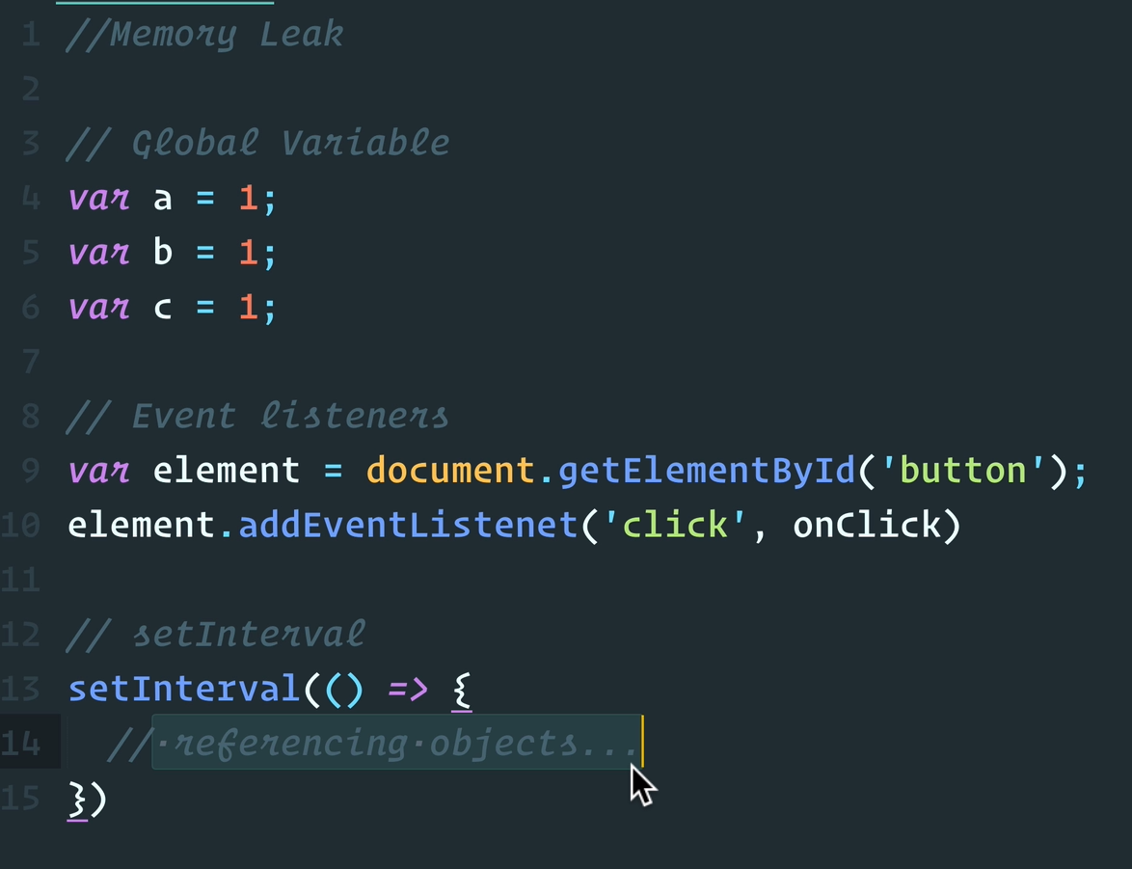

## JavaScript Runtime

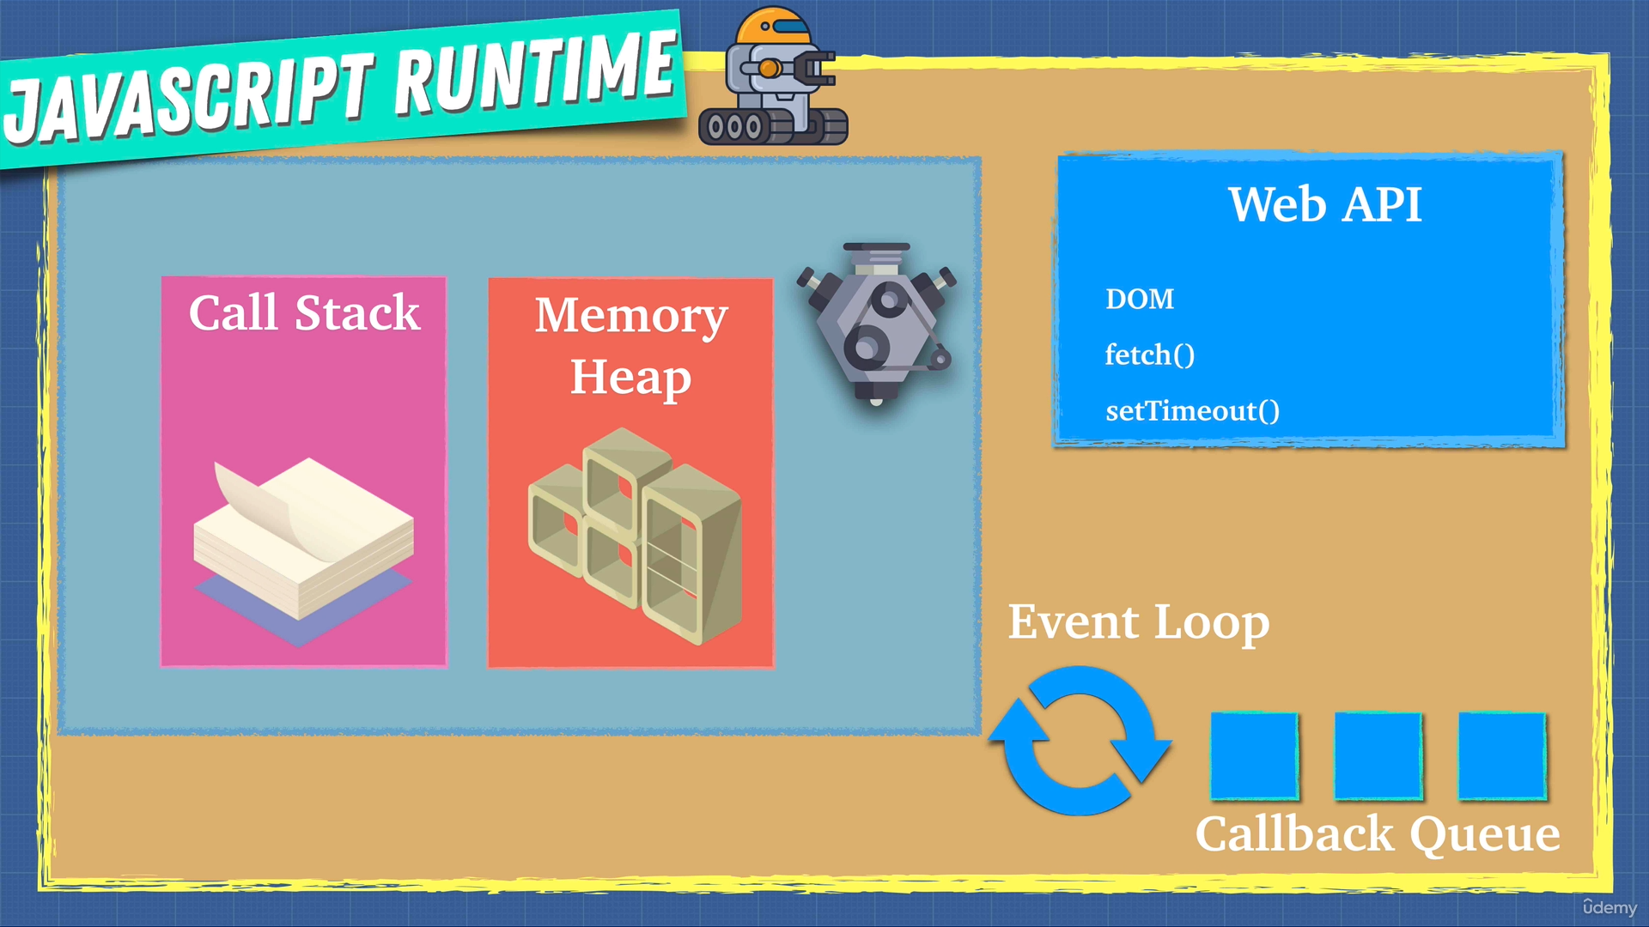

Each browser comes with a web API which can do DOM manipulation, API calls, and set timeouts. These web APIs are asynchronous. When the call stack encounters a web API call, it moves to the next statement and assigns the async call to Web API. Once the Web API finishes its work, the results are sent to the **callback queue**. An event loop constantly checks if the call stack is empty or not and if the entire file has been run. If it is empty and the entire file has been run, the results of call back queue are placed on the call stack. This is how asynchronous calls are handled in JS.

## Node.js

It is a JavaScript runtime built upon Chrome’s V8 JS engine. It’s a C++ program which provides a JS runtime outside a browser. Node.js can access users file system, etc which the conventional browser cannot do.

# JavaScript Foundation 2

## Execution Context

Execution context is the place where the code is run by a JS engine. By default, an engine gives **global execution context**, where you get a **global object** and a ***this*** keyword. Both point to the same thing. In a browser, the global object is *window* and both *this* & *window* are same thing.

On top of the global execution context, functional contexts are added. When a program is closed, the global execution context is the last thing to popped out from call stack.

## Lexical Environment

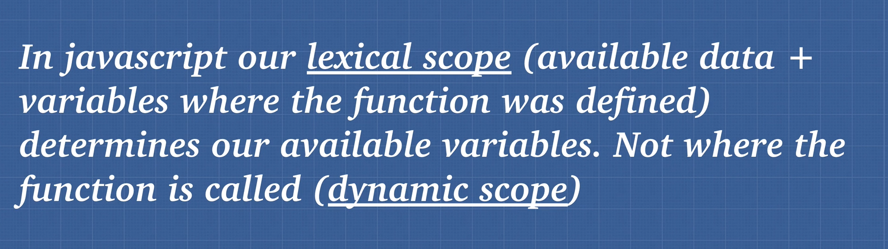

## Hoisting

The process of assigning space in the memory heap for *var* and *function* keywords before the program is executed, is called hoisting.

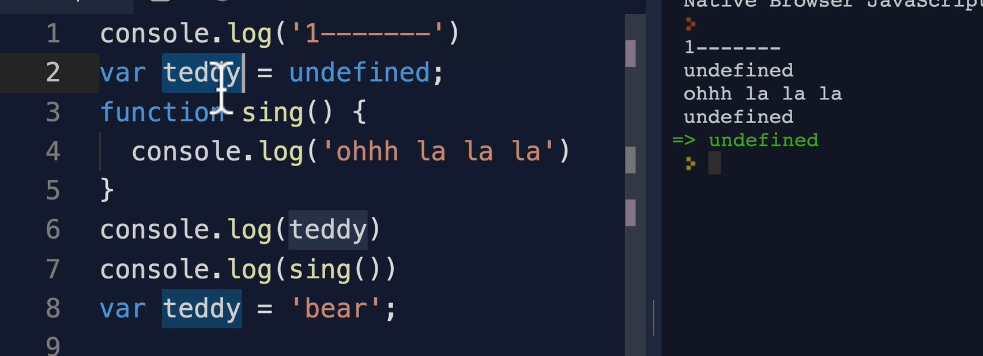

*Var* is partially hoisted. They are initialized with *undefined* status. Functions are fully hoisted, i.e., you can call the function before it is defined in a file.

Hoisting happens on each execution context. So, if there is a same variable name in a function like a global variable name, then the function variable name would be assigned undefined instead of global value.

**Sometimes hoisting can allow bugs to creep in. To avoid hoisting, use *let*** **and *const* keywords.**

## Function Invocation

### Arguments keyword

Just like we get *this* in the global context, we get *this* in a function context along with *arguments*.

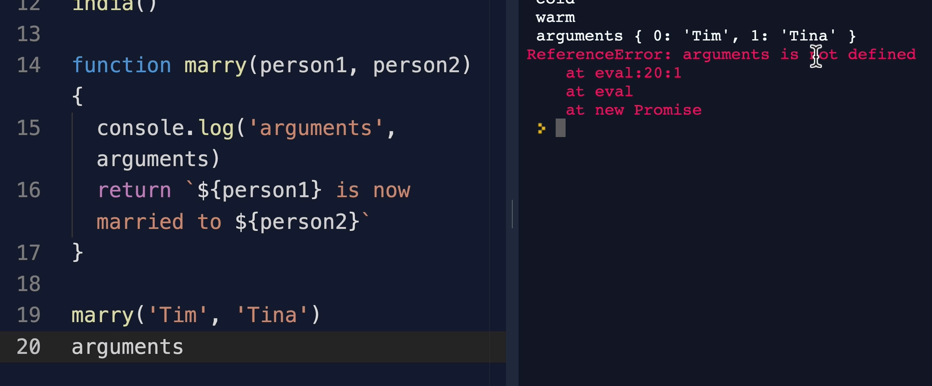

However, using *arguments* confuses the JS engine. To avoid this use *(…args)* which can be used in function scope as an array of arguments, just like in Python *\*args*.

## Function Scope and Block Scope

In function scope, the variables defined inside a block can be accessed outside of that scope. However, not in block scope. With ES6, *const* and *let* keywords introduced block scope. The keyword *var* does functional scope. So, if a variable is defined in a block of *if* statement and you do not want to access it outside that block, use *const* or *let*.

## Immediately Invoked Function Expression (IIFE)

An **IIFE** (Immediately Invoked Function Expression) is a JS function that runs as soon as it is defined.

**(function () {**

**statements**

**})();**

It is a design pattern which is also known as a [Self-Executing Anonymous Function](https://developer.mozilla.org/en-US/docs/Glossary/Self-Executing_Anonymous_Function) and contains two major parts:

1. The first is the anonymous function with lexical scope enclosed within the [Grouping Operator](https://developer.mozilla.org/en-US/docs/Web/JavaScript/Reference/Operators/Grouping) (). This prevents accessing variables within the IIFE idiom as well as polluting the global scope.
2. The second part creates the immediately invoked function expression () through which the JavaScript engine will directly interpret the function.

## *this* Keyword

The *this* keyword is the object that the function is a property of. Example;

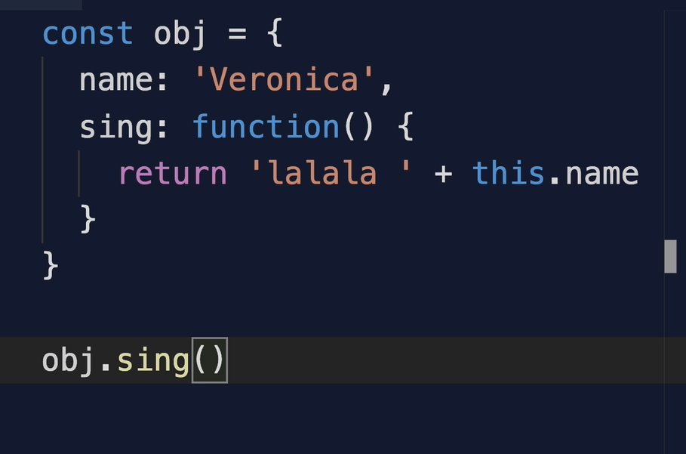

Here, *this* is the object that the function *sing()* is a property of, i.e., *this* is obj and so, we can access *this.name*. Its like the *self* of Python.

**READ MORE ABOUT STRICT MODE @** [Strict mode - JavaScript | MDN (mozilla.org)](https://developer.mozilla.org/en-US/docs/Web/JavaScript/Reference/Strict_mode)

The *this* keyword is not lexically scoped but dynamically scoped.

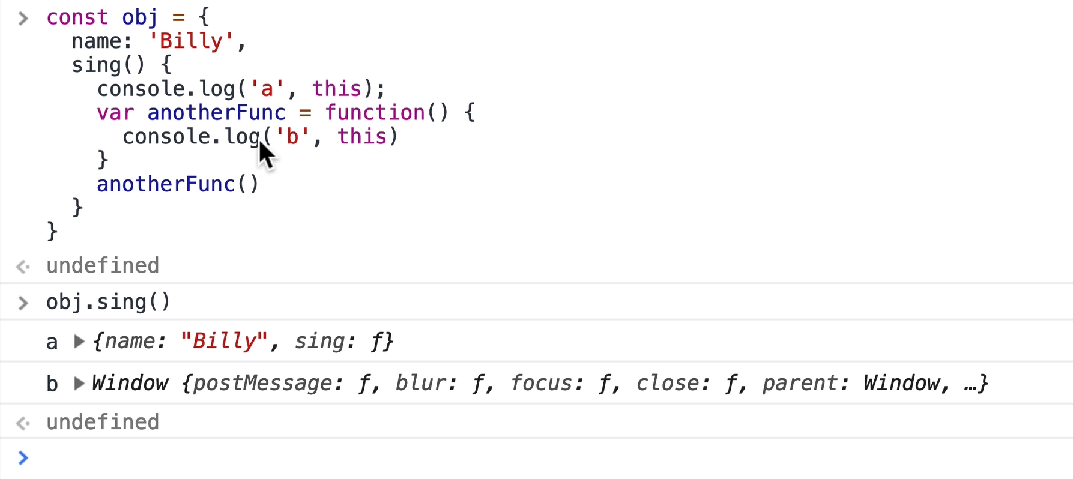

It depends on how the function is called. If no ‘.’, then *this = window*. How can we solve this? In ES6 we have arrow functions, so *anotherFunc* could have been defined by an arrow and that would mean that *this* now points to *obj* scope. Another way is to *bind* the *anotherFun()* using *anotherFunc.bind(this)*.

Another way is shown below

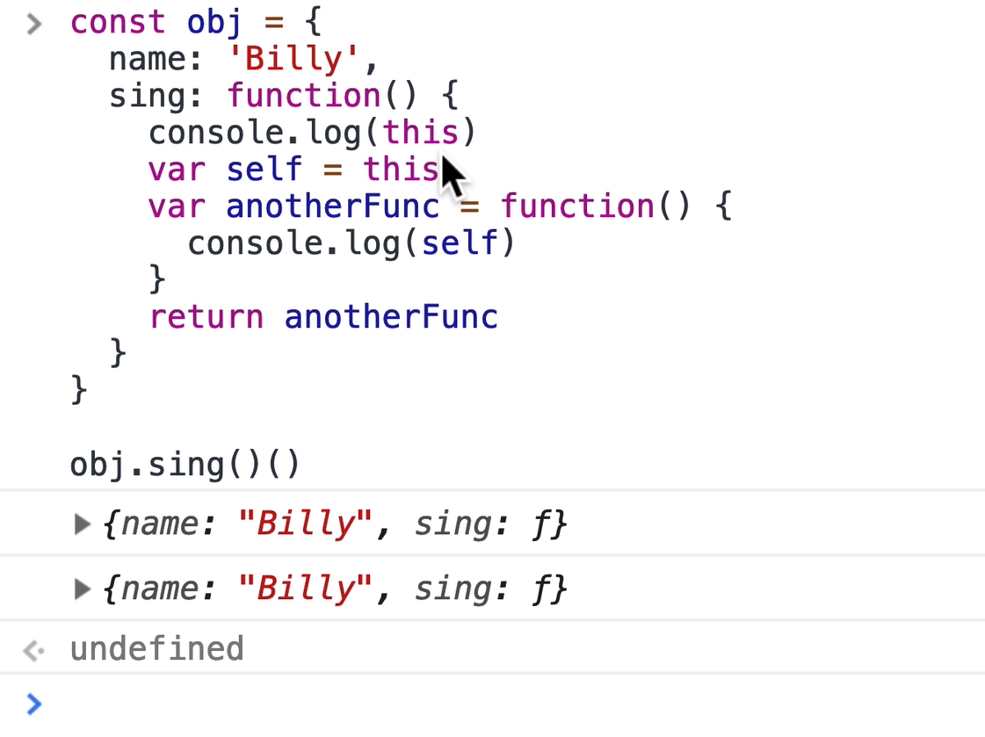

Here, we hold *self = this* where *this* points to *obj*. That way, we can use *self* in *anotherFunc*.

## *Call(), apply() & bind()*

The functions *call(), apply() & bind()* are used to borrow functions from another object. For example,

const wizard = {

name: 'Merlin',

health: 100,

heal: function(num1, num2) {

this.health += num1 + num2;

}

}

const archer = {

name: 'Robin Hood',

health: 50

}

wizard.heal.call(archer, 50, 60)

wizard.heal.apply(archer, [20, 30])

archer

// function borrowing

const healArcher = wizard.heal.bind(archer, 50, 60);

console.log(archer)

healArcher()

console.log(archer)

The call function in JavaScript simply calls the function. For example, *a() === a.call()*. That is, under the hood, all function calls call the *call()* method. Similarly, *apply()* and *bind()* also call *call()* internally.

Now from the example above, if we have a object function which we want to use in another object, in which we do not have that function, we can borrow it using *call()* or *apply()*, both do the same thing, just that in *apply()*, the arguments to the function are given as array.

The *bind()* function does not call the function, but returns another function (a copy), as shown in last 4 lines of the code above.

## Currying

The process of passing only partial arguments to a function using the *bind()* function is called currying. For example.

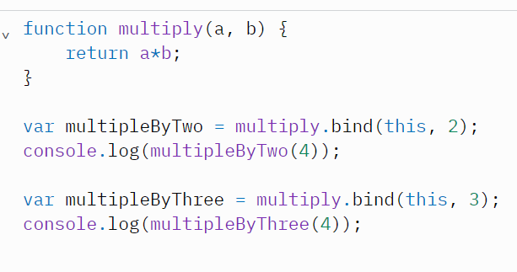

## Context & Scope

Context refers to the value of *this* keyword and scope is related to the visibility of variables depending on the functions. So, context is used in reference to classes and objects and scope is related to functions.

# Types in JavaScript

## Types in JS

1. Numbers
2. Boolean
3. String
4. Undefined
5. Null
6. Symbol (new in ES6)
7. Object {}

**Note that *typeof null* returns *object*, which is already a type. This is a mistake in JS and is not being rectified because many code bases are now designed by assuming that null is object and it will break things if rectified.**

**There are no function and array data types because**

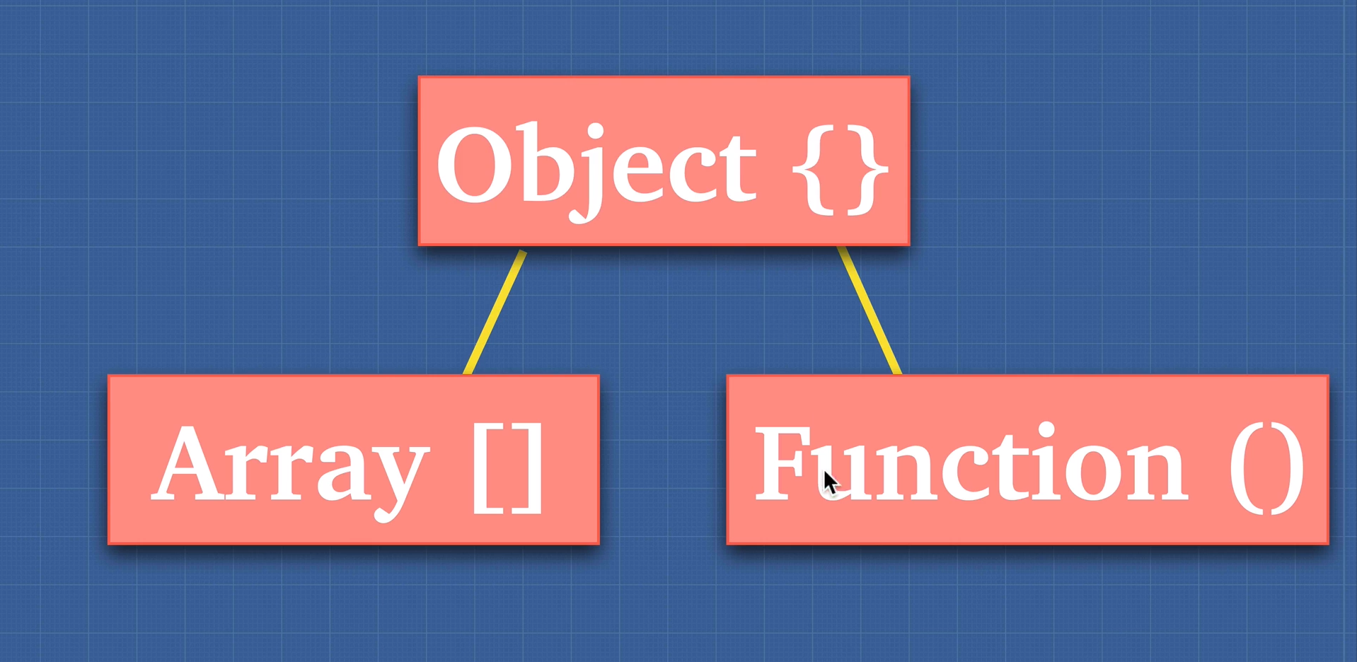

Functions are objects because for any given function, you can assign a new property to it, just like an object.

### Primitive types

A primitive type is a data structure which holds the value directly. 1 to 6 above.

### Non-primitive types

A non-primitive type is a DS which does not hold the value directly. 7th above.

[Standard built-in objects - JavaScript | MDN (mozilla.org)](https://developer.mozilla.org/en-US/docs/Web/JavaScript/Reference/Global_Objects)

**Note: All primitive types in themselves are objects. *true.toString() 🡪 ‘true’* why? Because true is actually converted to *Boolean(true)* so that toString() can be invoked.**

## Array

In JS, an array is an object itself.

*[1,2,3] === {0: 1, 1: 2, 2: 3}*

We can check if an object is an array or not using *Array* class. *Array.isArray(obj)*.

## Pass by reference & value

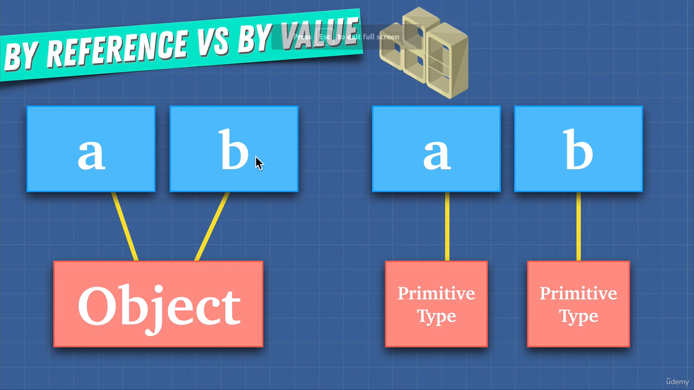

In JS, only objects are pass by reference. That is, if both *a* and *b* point to the same object, changing property using *a* will change the property in *b* also. That is not the case with primitive types. Both *a* and *b* when assigned same values are pointing to different locations in the memory. This makes object occupy less space in the memory heap.

### Cloning objects

#### Cloning array

*let d = [].concat(c)*

#### Cloning object

*let d = Object.assign({}, c)*

*let d = {…c}* using ES6

**NOTE: If there is a nested object, then while copying the parent object, the nested object’s address will be copied, and this will change the properties if changed somewhere else. This is called shallow cloning.**

To do deep cloning, use this **JSON.parse(JSON.stringify(obj))**.

## Type Coercion

Type coercion is the process of forcibly converting operands to same type while comparing. For example, *1 == ‘1’* will return *true* because here type coercion takes place. If you want to compare explicitly, use ===, i.e., *1 === ‘1’* will return *false*.

Resources:

1. [JS Comparison Table (dorey.github.io)](https://dorey.github.io/JavaScript-Equality-Table/)
2. [ECMAScript Language Specification - ECMA-262 Edition 5.1 (ecma-international.org)](https://262.ecma-international.org/5.1/#sec-11.9.3)

## Dynamic and Static Typing

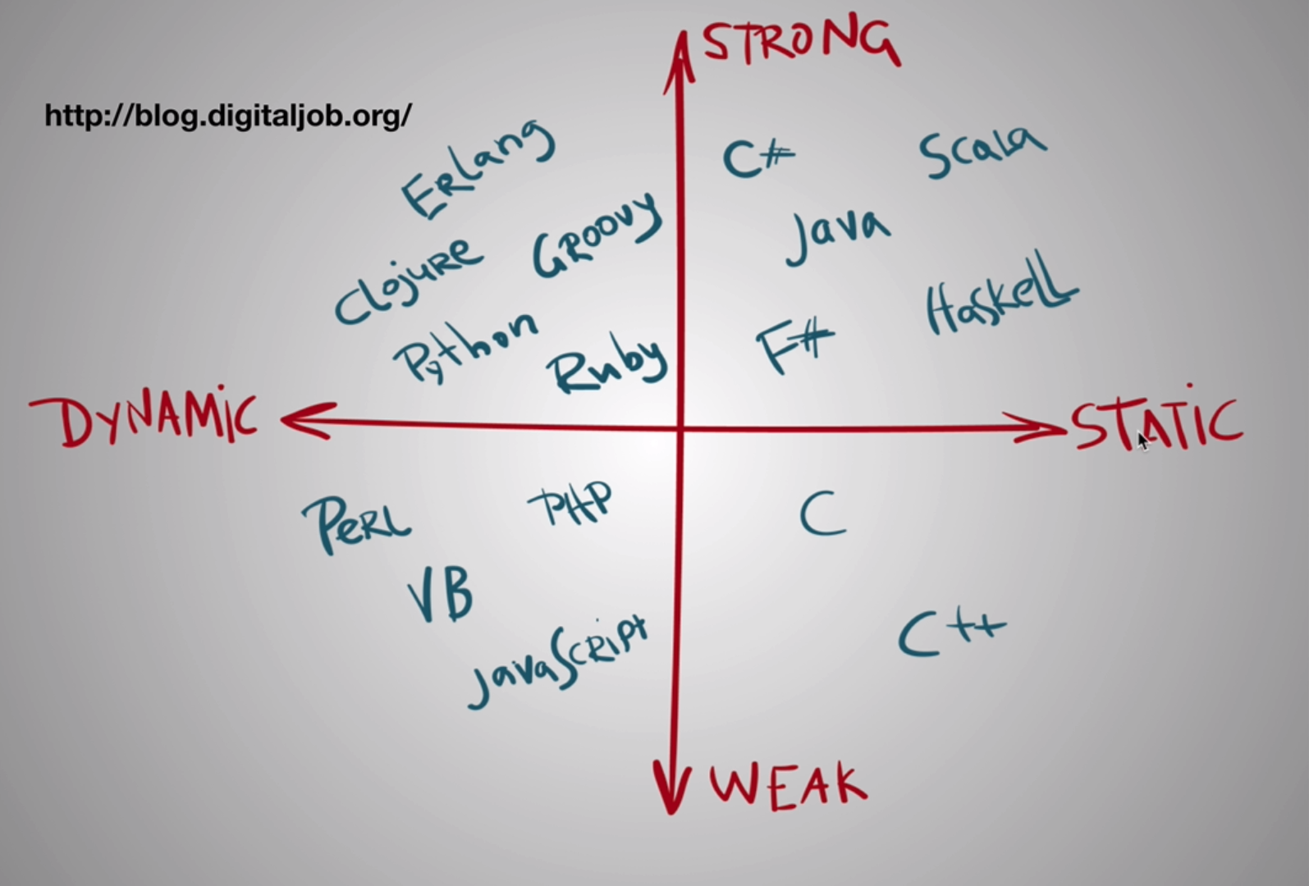

A dynamically typed language is one in which you don’t need to define the type of variable before initiating it, on the other hand, a static typed language needs type defined before assigning values. **TypeScript** makes **JavaScript** static typed by adding these checks into it.

Pros of static type is that it is self-documented and has less bugs in production, but it is complex to work with and is also slow to quickly deploy because it reports bugs even before deployment (a pro).

## Weak and Strong Type

JS is a weakly typed language. A weakly typed language is the one in which type coercion happens while doing operations. For example, *“a” + 18 = “a18”*. In Python, for example, which is strongly typed, this would raise an error.

**NOTE: Babel takes ES 6, 7, 8 code and converts into ES5.**

## Static Typing in JS

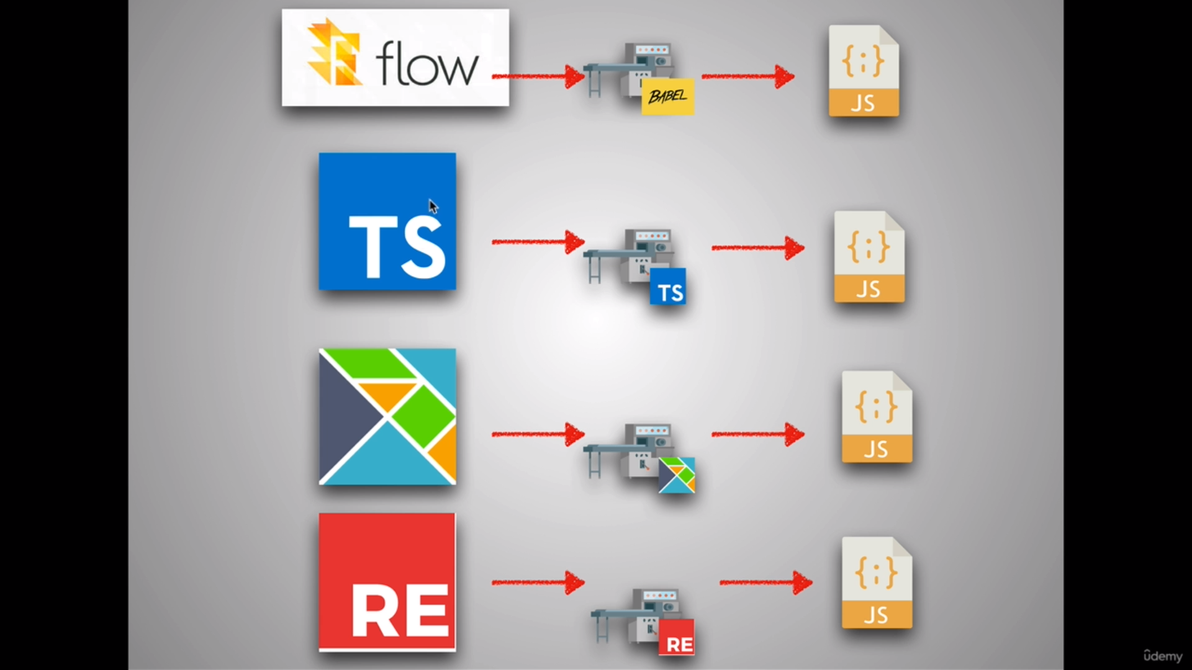

1. Flow comes with *create-react-app*.

# The 2 Pillars: Closures and Prototypal Inheritance

## Functions

* Functions in JS are objects.
* Functions are first class citizens in JS.
  + A function can be assigned to a variable.
  + A function can be passed as an argument to another function.
  + A function can be returned from another function.
* With ES6, you can pass default values of parameters in a function.

## Higher Order Functions

A higher order function is a function that accepts another function as an argument or returns another function.

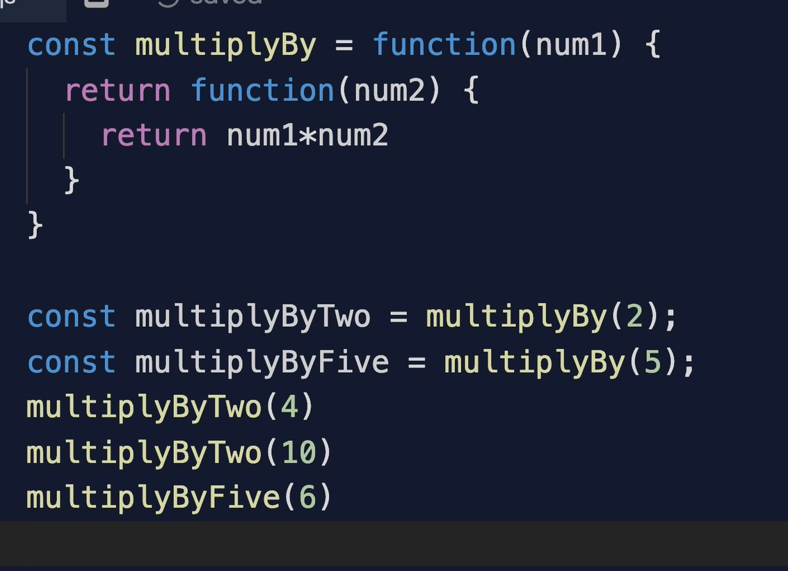

## Closures

This is one of the most important concepts in JS. Closure means *function + lexical scoping*. It basically means that in a higher order function, the returned function can have access to the variables of parent functions. This is quite trivial. Let’s see what happens on engine side.

When a parent function is called and its variables are initialized, as soon as it returns another function, according to the principle of call stack, the variables of the parent function must be removed. However, since JS is lexically scoped, it knows beforehand what all variables are being referred in the child functions. So, the garbage collector ignores those variables and the JS engine keeps them in a memory location called **closure**. However, those parent variables which are not being used by child functions will be removed by the garbage collector.

Please read this [what is closure in javascript, advantages and disadvantages? | by Deepak Mankotia | Medium](https://deepakmankotia.medium.com/what-is-closures-in-javascript-7acc626281ab). A **very good** article on closures.

Let’s see this example code

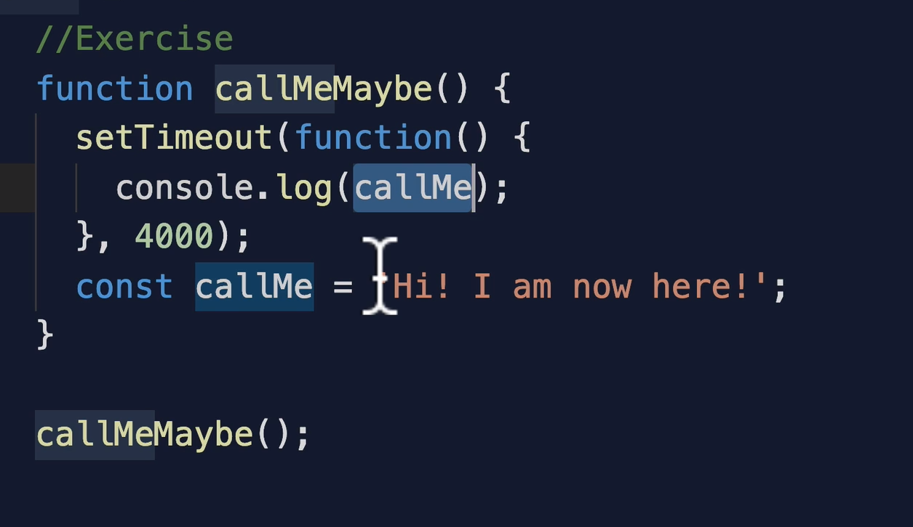

Here, the Web API is using the concept of closures to hold on to the variable *callMe*. Even if it is defined after the *setTimeout()* function, the variable does not get popped off, instead it is stored in a closure.

Let us understand two main advantages of closures.

1. Memory efficiency
2. Encapsulation

Let us demonstrate these two concepts using Python, since Python too supports closures.

### Memory Efficient

Suppose we have a function called *access()* which creates an array each time it is called and returns the value at an index which the user has asked for. The problem with this function is that each time it will create a new memory allocation and will quickly fill up the space.

def access(index):

a = [i for i in range(100)]

print("created")

return a[index]

We can solve this problem by using closures. Create another function, which creates the array only once and returns another function to access the values inside it.

def closure():

a = [i for i in range(100)]

print("created only once.")

def access1(index): return a[index]

return access1

The benefit now is that we only create the array *a* only once. Here is how to use it.

f = closure()

This will print *created only once.* Now you can use *f()* to access the value in *a*. Note that the closure function itself does not take any parameter but *f()* will. So, *f(90)* will return 90 but now the array is not created again.

### Encapsulation

Closures also benefit with encapsulation. Encapsulation is the concept of hiding variables or functions to the outside world. See the code below for instance.

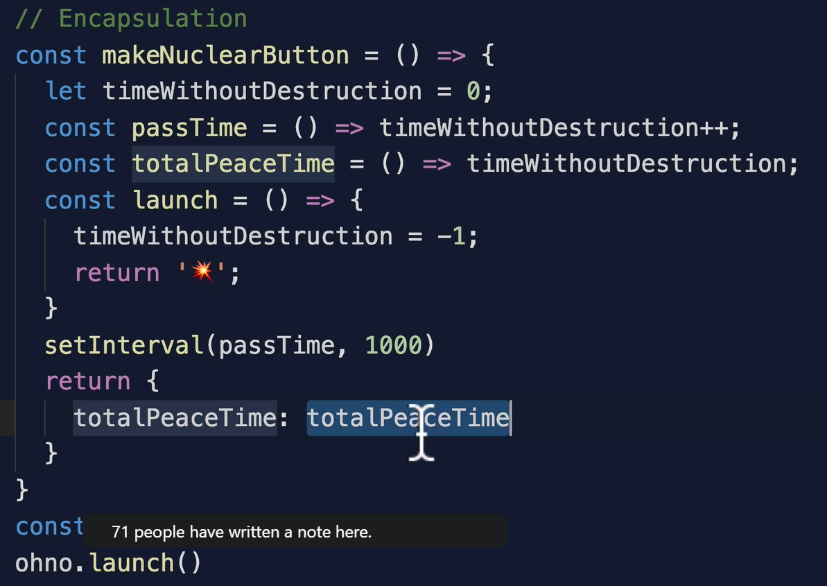

In this, we see that the user has access only to a function which returns time without destruction. The user cannot use the *launch()* function or cannot change the value of time without destruction. Later on, we will see how IIFE can be used for encapsulation.

### Exercise

See the code below

const array = [1,2,3,4];

for(var i=0; i<array.length; i++) {

setTimeout(function() {

console.log(array[i]);

}, 3000);

}

Now, when you run this code, it will print 4,4,4,4. That is, the reference to *i* is lost in the loop because of the 3 second time. How can we print all the elements of the array?

**Solution 1.** Change *var* to *let* in the for loop’s *i* initialization. That will solve the problem or

**Solution 2.** Use closures + IIFE.

const array = [1,2,3,4];

for(var i=0; i<array.length; i++) {

(function(closure_i) {setTimeout(function() {

console.log(array[closure_i]);

}, 3000)})(i);

}

The second solution is more appropriate.

## Prototypal Inheritance

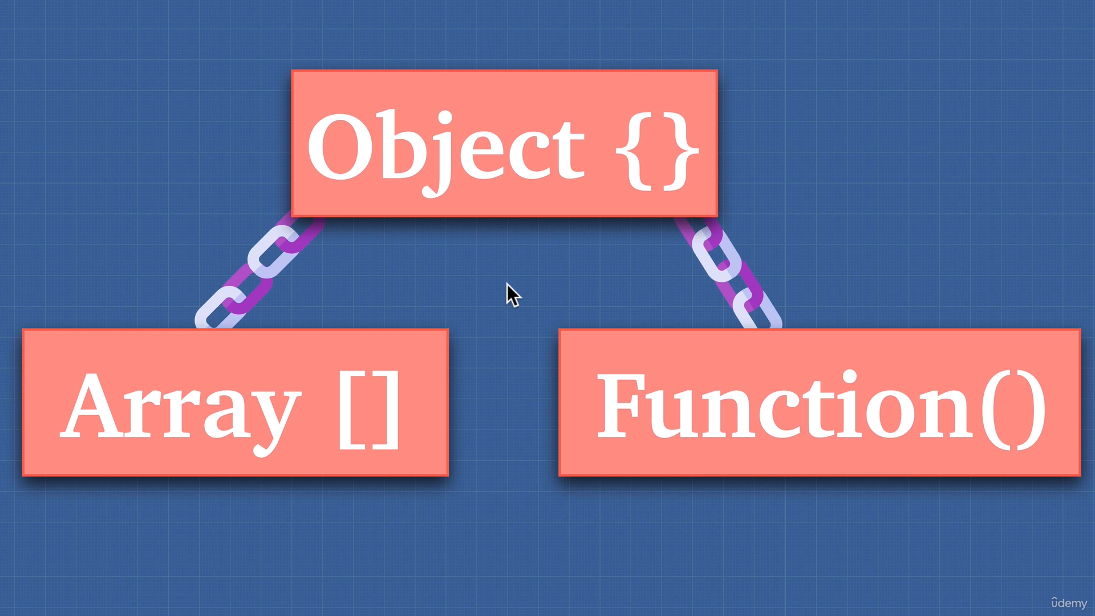

Prototypal inheritance is a concept unique to JS where methods and properties can be added to an object. It is a method by which an object can inherit the properties and methods from another object, just like functions and arrays inherit from base object, in JS. Languages like C and Java use classical inheritance which is different from prototypal inheritance. The inherited object can be accessed in JS by accessing *obj.__proto__*.

To inherit another object in an object *obj1*, we can do this: ***obj1.__proto__ = another_object***.

This way *obj1* will have access to all the methods and variables in *another_object*. If a user calls something which not in both *obj1* and *another_object*, the JS engine will then look for that property from which *another_object* inherits.

Although you can manually set up prototype chains as shown just above in **bold**, but you should never do that in real. This confuses the compiler and is also a bad practice. We will see how to do proper prototype chaining later.

**NOTE: If you do *{}.__proto__.__proto__*, it will return *null*. This is useful when raising errors to the user when they try to access something that is not present in the object.**

**NOTE: *__proto__* is a pointer which points to *prototype* property in the parent object. The ­*__proto__* property itself lives in the ­*prototype* property of the object from where it is called. Below diagrams illustrate this.**

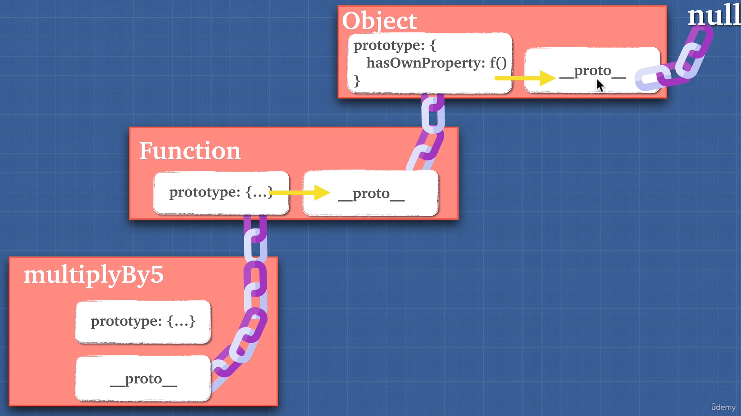

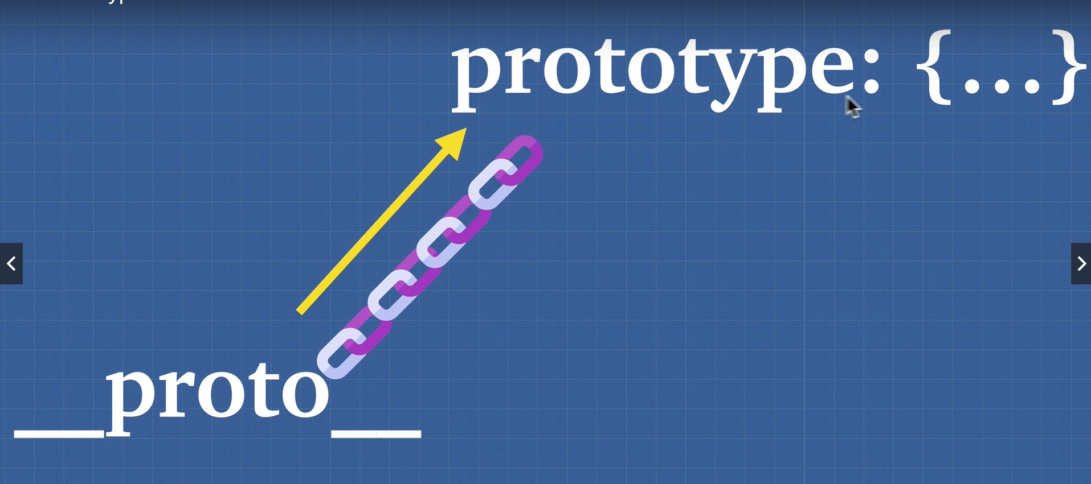

**The correct way of inheriting from another object is *newObj =* *Object.create(another_object);*.**

**NOTE: Only functions in JS have prototype property, not objects, or arrays or strings or any other primitive types, only functions. So, *{}.prototype* will give *null*.**

# Object Oriented Programming (OOP)

Back in 1980-1990s, there were two programming languages which popularized the idea of two paradigms. The first one was the **Scheme** programming language which emphasized on the **Functional Programming (FP)** and the other was **Java** which emphasized on OOP. OOP says that both the data and the behavior (methods) of an object must be stored in a same location, i.e., a class. FP says that these two are different things and must be stored separately. Both are correct at their own places and we will see when to use what.

In OOP, there are two ways of creating objects; either use classes or use prototypes.

## Factory functions

A factory function is a function in JS that returns objects (initiates them) and therefore acts like a factory.

const carBuilder = (model, color, fueltype) => {

return {

model,

color,

runsOn() {

return `The car runs on ${fueltype}`;

}

}

}

This function is a factory function because it acts like a factory for creating cars. The problem with this function is that for each car, name and color could be different but the *runsOn()* function is common to all cars, isn’t it? We are creating useless copies of it for all the cars. Why not create a common *runsOn()* function and inherit it in other objects? To do that, see below.

const carFunctions = {

runsOn() {

return `The car runs on ${this.fueltype}`;

}

}

const carBuilder = (model, color, fueltype) => {

let car = **Object.create(carFunctions)**;

car.model = model;

car.color = color;

return car;

}

This way, we are now using only one *runsOn()* function.

## Constructor functions

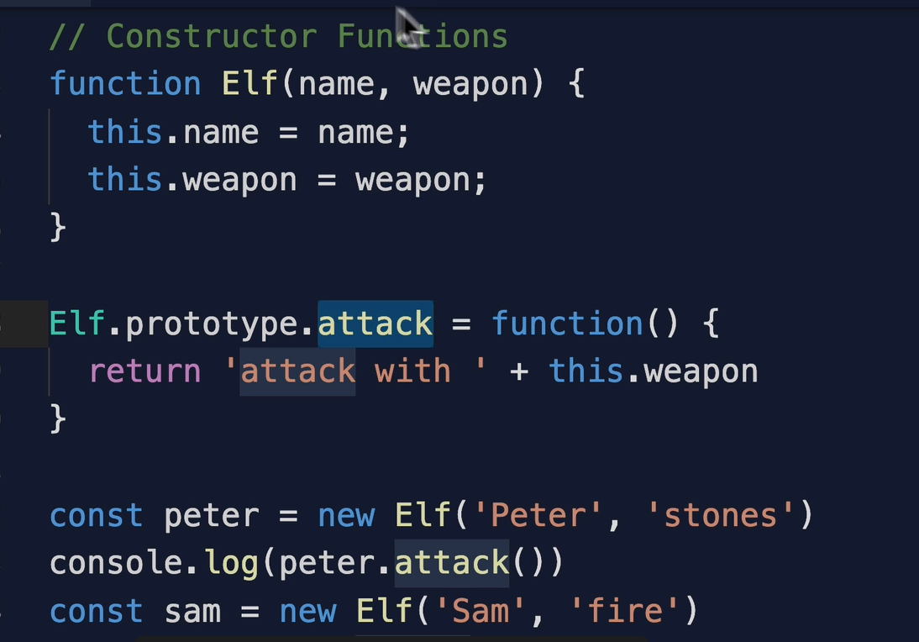

Here, the constructor function is *Elf()*. To initiate, we use the *new* keyword. Each constructor function comes with a prototype variable which can have new functions or variables attached to it. This ensures scalability. Example, the *attack()* function above.

**NOTE: The attack function is not using arrow function because those are lexically scoped. That is, when calling attack using arrow functions, the output will be *“attack with undefined”*. This is because the *this* keyword would then point to lexical scope, i.e., global. However, using *function()* which is dynamically scoped, the *this* keyword will point to the object which is calling that function.**

**NOTE: Using constructor function methods on primitive data types is possible because when you do that, JS understands that you want to use constructor methods and it internally converts those primitive data types to constructor data types.**

**NOTE: JS have classes, but it is syntactic sugar, i.e., under the hood, JS is still using prototypal inheritance to define classes. In pure OOP languages, classes are pure entities.**

## *this* bindings

1. Using *new* keyword.

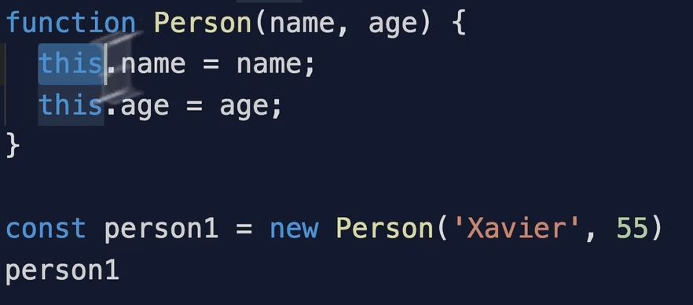

1. **Implicit binding**

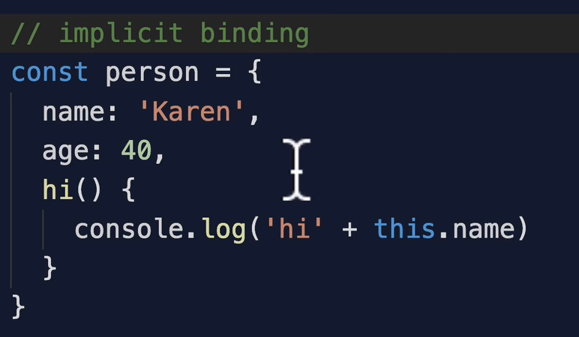

1. **Explicit binding**

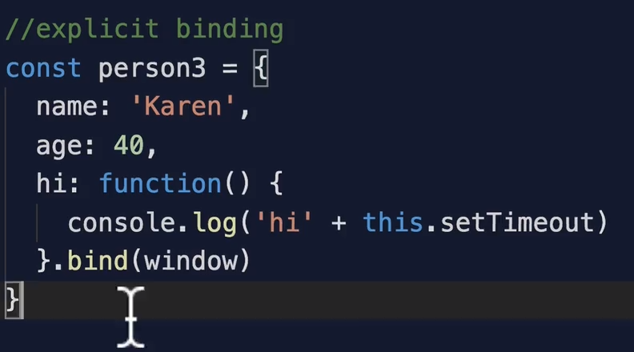

1. **Arrow functions**

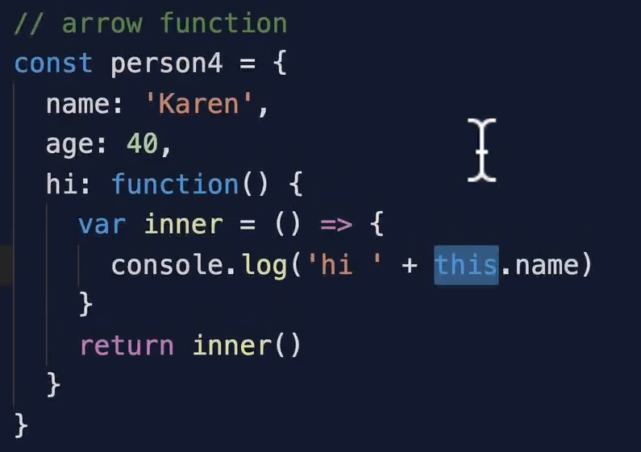

## Inheritance

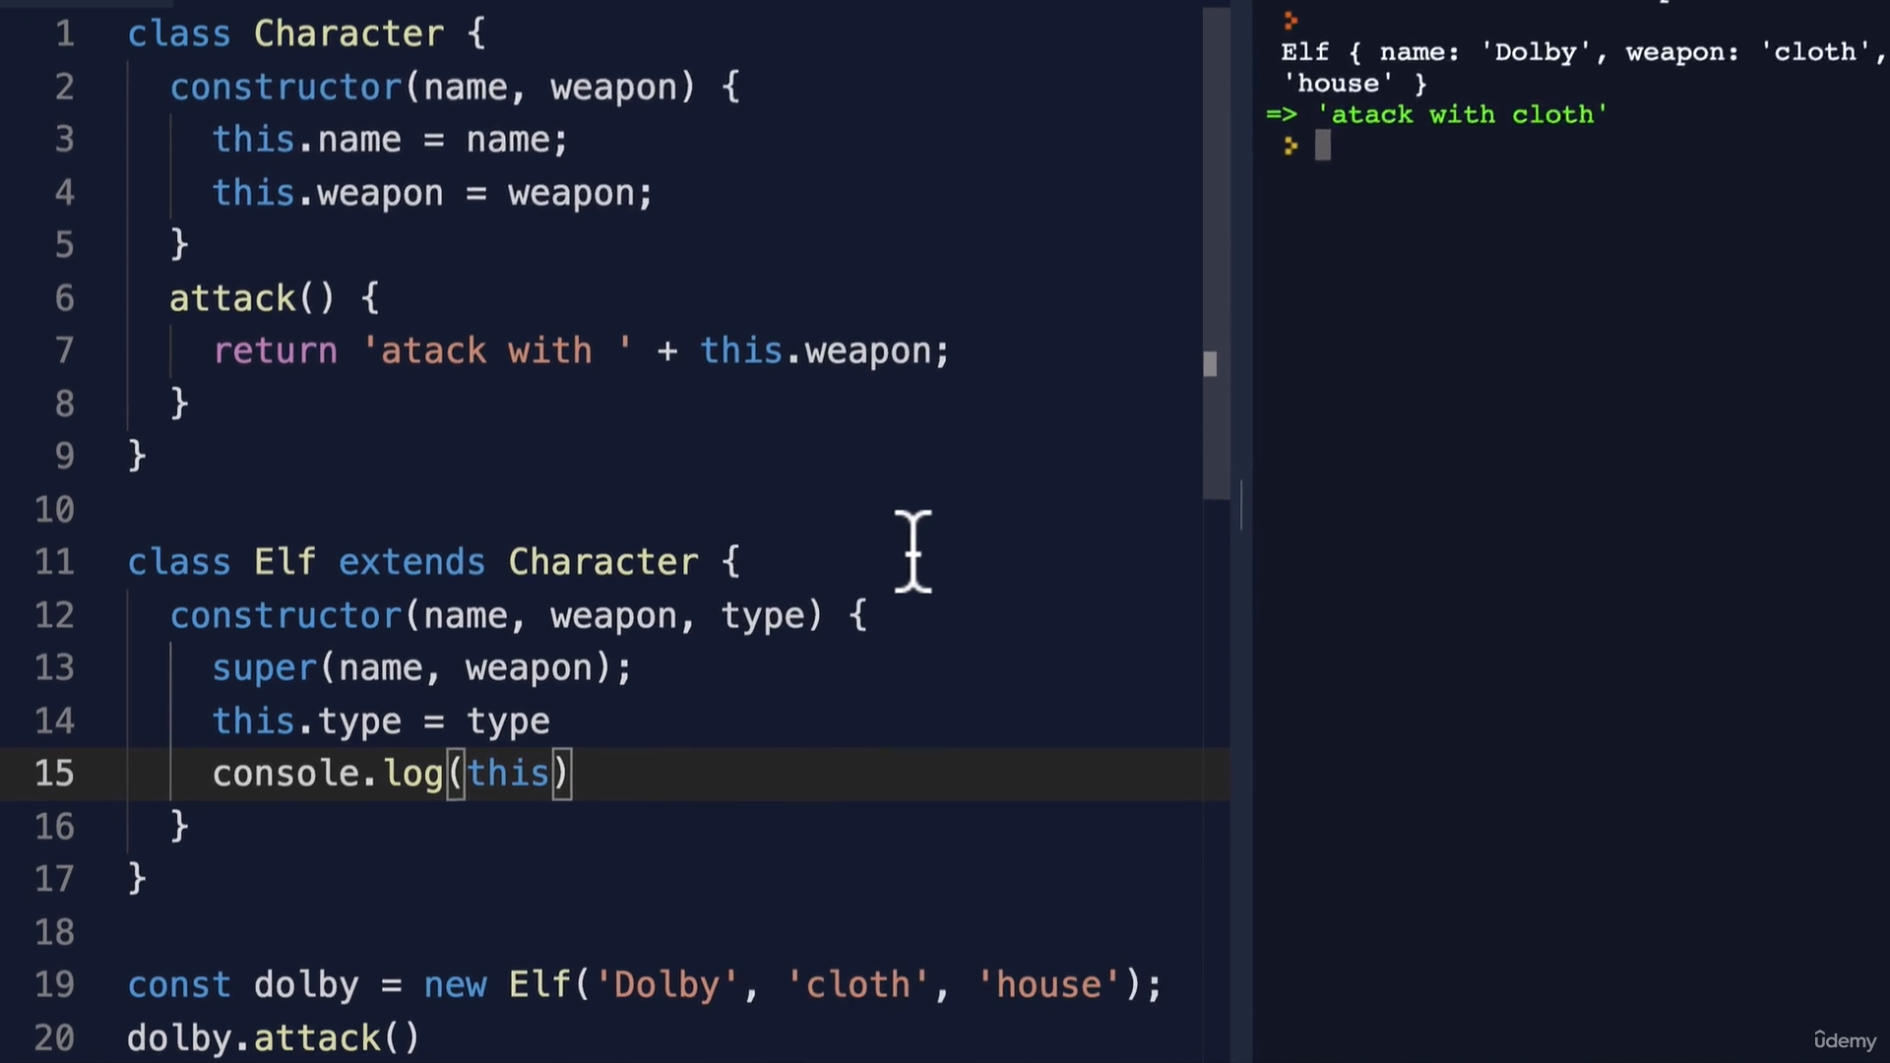

Elf inherits from Character class. This is a classic example of open for extension and closed for modification.

## Public & Private

With any OOP language, the concept of private variables or methods comes up. JS does not have this private concept. However, you can use *#* symbol to make a variable inaccessible to the outside world. However, the variable should not be defined in the constructor.

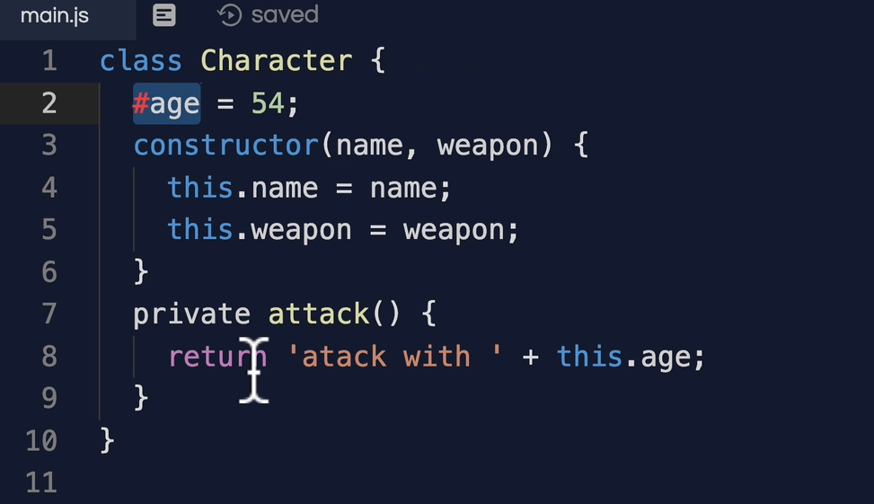

## Four Pillars of OOP



1. Polymorphism
   1. The ability of a method to behave differently in different classes.
   2. If there are two classes that inherit from same interface, then they can have their own implementations of the interface methods.
2. Inheritance
   1. The process of basing a class on another class
   2. Need to use *super* in the constructor method to invoke the base class
3. Abstraction
   1. The process of hiding intricacies and complexities behind a class.
   2. Example; a Car class can be used to create a car. The end user does not need to worry about how the car will be created but just how to use the methods and variables.
   3. It makes code more easy to understand.
4. Encapsulation
   1. Putting different logic in one place, just like in a class.
   2. Encapsulation and Abstraction are highly inter-related.

# Functional Programming

## Pure Functions

A pure function is a function which

1. Returns the same output for same input.
2. Has no side effects, i.e., it does not modify anything outside of its scope.

Below shown is a pure function.

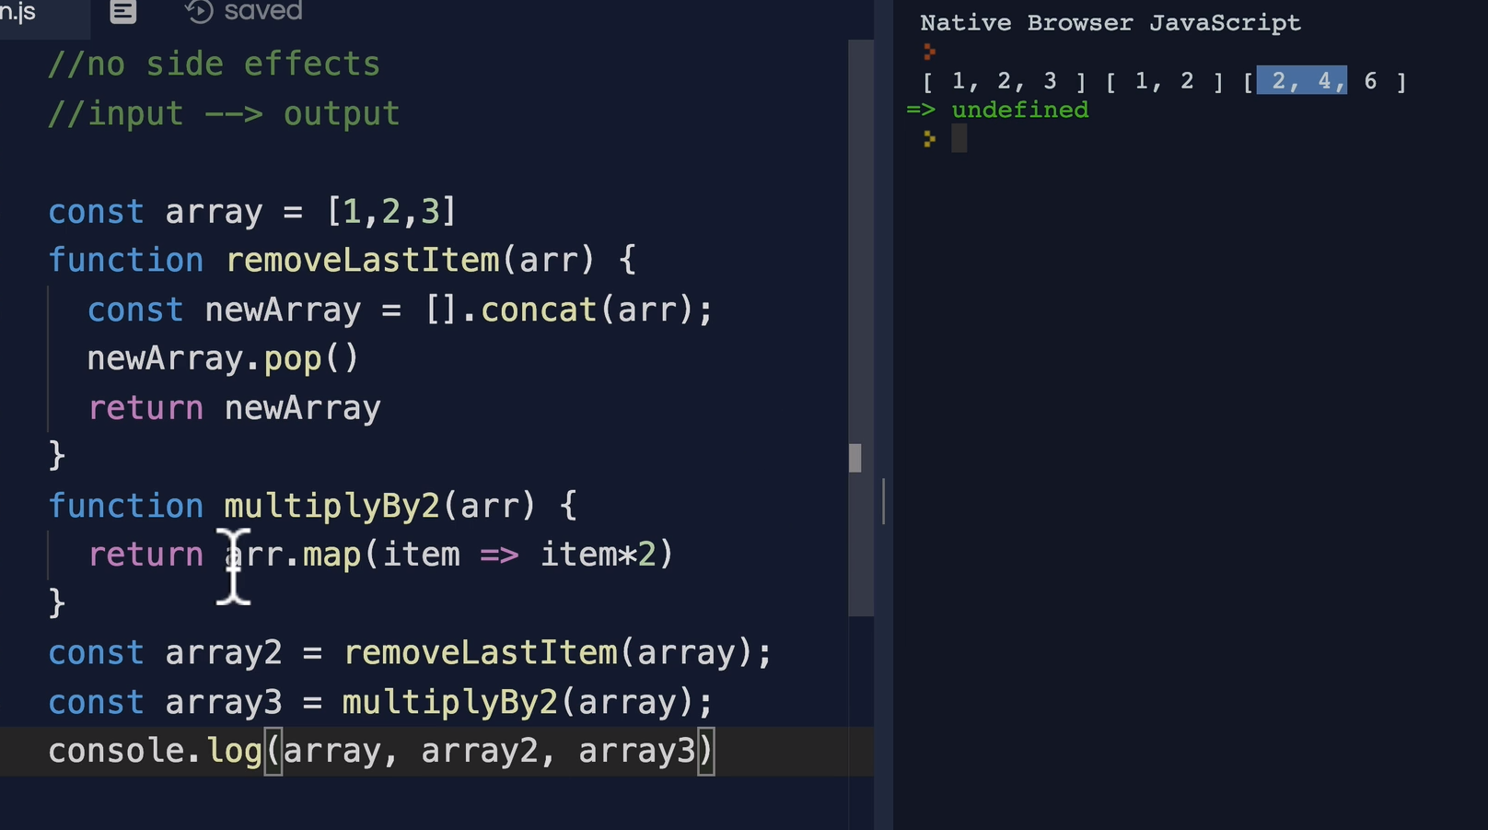

These two functions return a copy of modified array, instead of modifying the original outside array.

### Referential Transparency

**Referential transparency** and **referential opacity** are properties of parts of computer programs. An expression is called referentially transparent if it can be replaced with its corresponding value (and vice-versa) without changing the program's behavior.

There is nothing like pure functions in real world. And having an impure function is not bad. Because, according to pure functions definition, if you are not modifying anything outside the function, then you are not interacting with the code. So every program needs to have impure functions.

**NOTE: Closures can imply impure functions because a closure function modifies the variable to which it is referring to inside the returned function. However, closures can also be pure if they just reference the outer variable without modifying it, like getting the latest value, etc.**

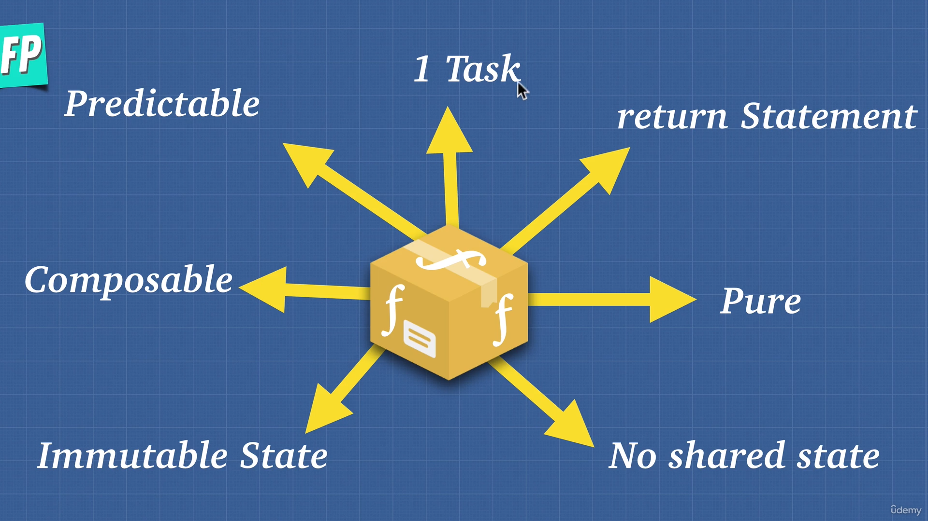

## Idempotence

The property of a function to return same output however times it is called in a nested way.

$$f\left(a\right)=f\left(f\left(a\right)\right)=f\left(f\left(f\left(a\right)\right)\right)=…=k$$

## Imperative and Declarative

An imperative way of coding is where you tell the machine the exact steps to follow, just like the assembly language, i.e., in which register to move the variable, etc.

A declarative way of coding is where you just tell the machine what to do but not how to do it. All high level languages are declarative.

For example, jQuery is imperative and React is declarative. In jQuery, you need to tell how to do even small things like displaying the text etc. Being imperative is too manual. But at the end of the day, all declarative languages decode to imperative world.

## Immutability

The concept of not changing the original object and instead applying the changes on the copy of that object is called immutability. It’s a core principle in functional programming. It might seem memory inefficient but there are ways to bypass that, like **structural sharing** about which you can read more at [Immutable.js, persistent data structures and structural sharing | by Thai Pangsakulyanont | Medium](https://medium.com/@dtinth/immutable-js-persistent-data-structures-and-structural-sharing-6d163fbd73d2).

## Partial application

It is like currying but in currying we return another function, however, here we apply partial arguments in the same function.

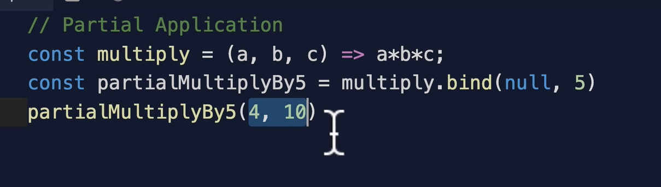

However, in currying it might be something like this.

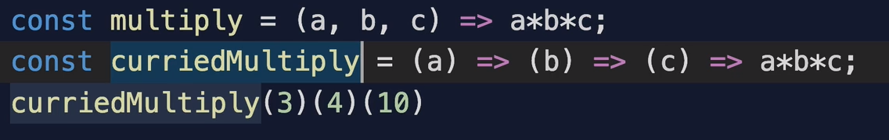

The *bind* is using *null* to reference *this*.

## Memoization

The process of storing input-output values in a cache object on first call of the input so that when the same input is called again, we do not need to calculate values again, instead just return from cache.

## Compose

The concept of compose is that it is a function which takes two or more functions as input and applies them sequentially on data, just like an assembly line in a factory. JS does not come with a compose function inbuilt. Here is an example of compose function built from scratch.

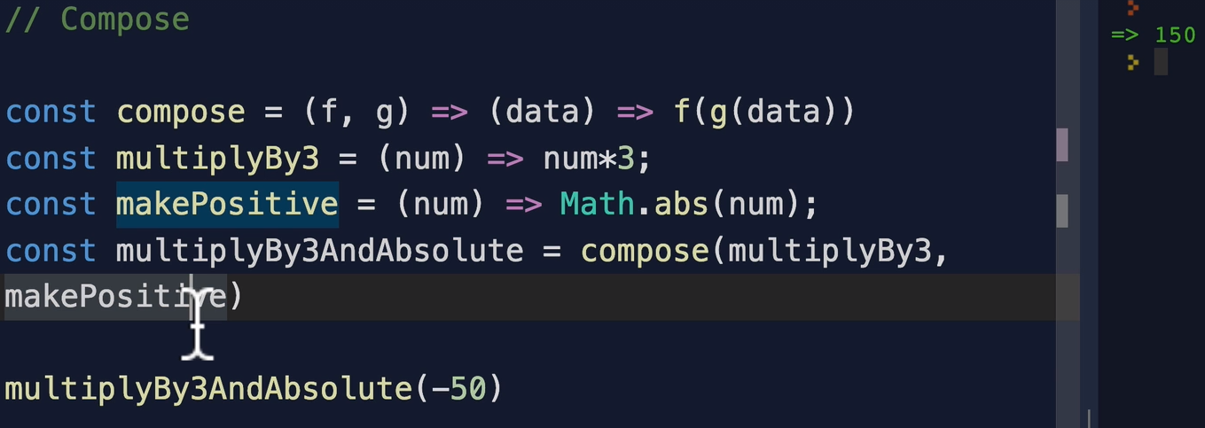

The *compose()* function takes in two functions and returns another function which takes in the *data* on which to operate and first applies the *g()* function and then the *f()* function and returns the value.

### Pipe

The pipe technique is just exactly same as compose technique but in pipe the order of function application reverses. In the above image, according to compose, *g* is applied first and then *f*. In pipe, *f* will be applied first and then *g*.

**NOTE: There is a term called *ARITY* in FP. Arity means the number of arguments that a function takes.**

**NOTE: FP is not the answer to every programming problem. Sometimes it is good to use OOP also. FP makes the program predictable and simple to use and is thus used extensively in distributed systems. There is no concurrency in FP but it is simple to extend and use.**

# OOP vs FP

## Inheritance vs Composition

1. Composition means bringing small functions together into a bigger composite function and inheritance means to extend the functionality of a single class to a larger class.
2. OOP is *“What it is”* type and FP is *“What it does”*.

### Problems with Inheritance

1. It makes the code tightly coupled, i.e., a child class or its children might get affected by even a very small change in the base class.
2. Class structure is highly hierarchical, therefore, if some child wants to go up to the parent level, it can easily break things.
3. It also has **Gorilla-Banana** problem. Basically, if a child class only needs few functionalities from the base class, you still get all the methods and variables from the base class, just like asking for banana but getting it along with the gorilla.

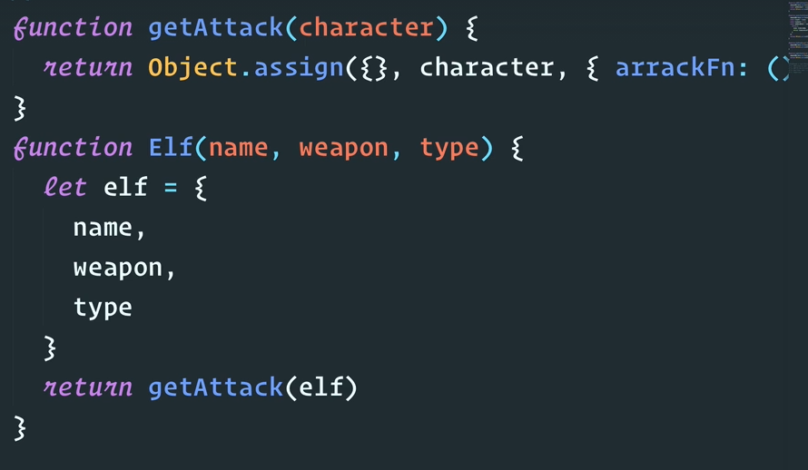

This is how FP can solve the problem. We do not inherit any *attack()* function from any class but instead, we take the object and give it a new property using the *getAttack()* function and then return the modified object.

### Comparison

1. In OOP, objects are first class citizens and in FP, functions are.
2. FP is more mathematical but in OOP its about hiding irrelevant information by abstraction and encapsulation.
3. FP is about more operations on fixed data and OOP is about few operations on common data.
4. FP is stateless, you should not modify the state. In OOP, its stateful, and you can touch and change the state.
5. In FP, functions are pure. OOP has side effects because it manipulates the state.
6. FP is declarative and OOP is imperative.
7. In FP, data and behavior should be kept separately, but in OOP they should be in same lexical scope.

# Asynchronous JavaScript

Asynchronous means something that is to be executed later. JS is a single threaded language and therefore there is this concept of Web API and callback queue to make these async operations possible.

## Promises

Promise is a new add-on in the ES6 JS. A promise is an **object** that may produce a single value some time in the future, either a resolved value or the reason that it is not resolved. Promise has 3 states.

1. Fulfilled
2. Rejected
3. Pending

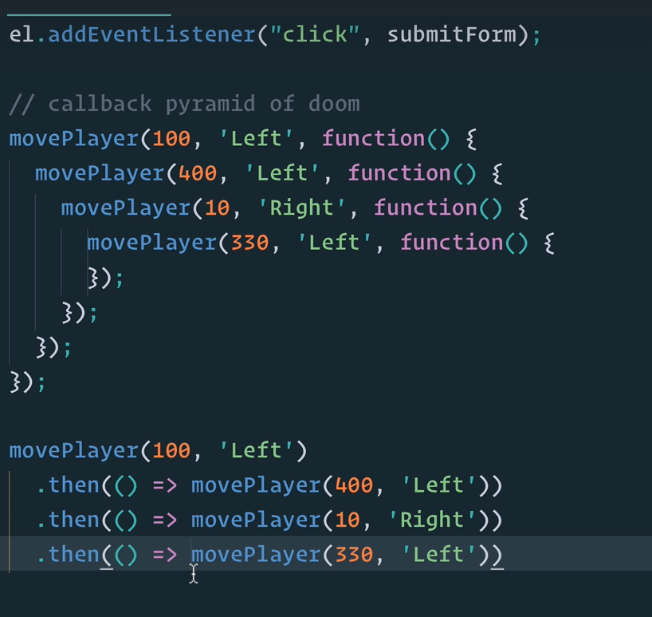

The two methods shown in the figure above are *callbacks* and *promise*, respectively. The promise looks more readable. There is also a *.catch()* statement along with *.then()* in promises. A *.catch()* catches the errors of all the *.then()* which occur before it.

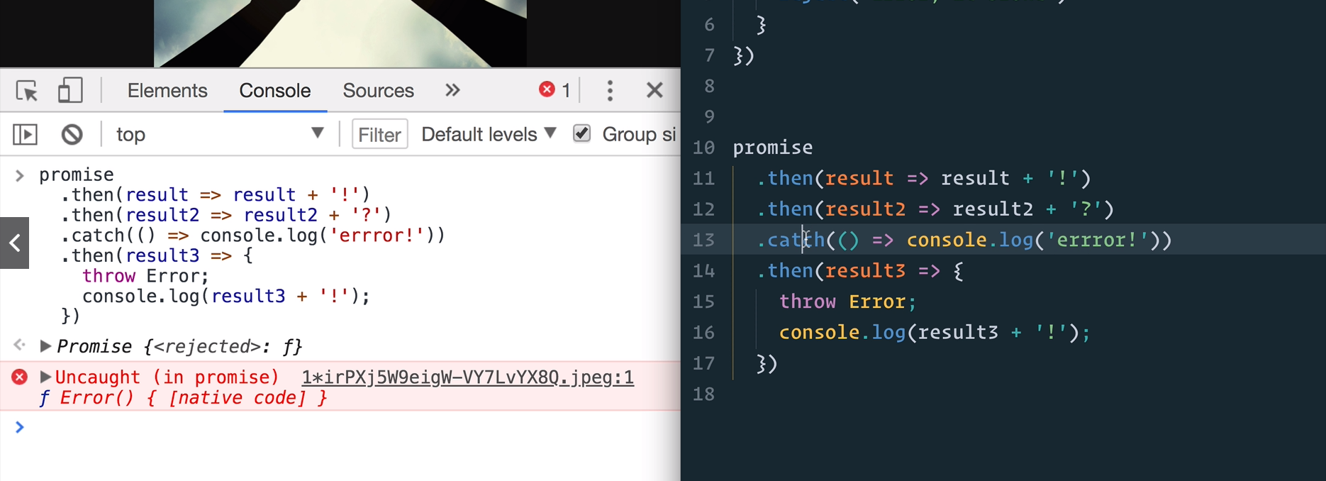

If you see the above image, there is an error in the *.then()* which is after the catch statement. Here, catch won’t work and we see that the error is thrown on the browser’s console.

### Promise.all()

This is a feature in promises where you pass the promise variables as an array to this function and it returns the result after the longest promise is done.

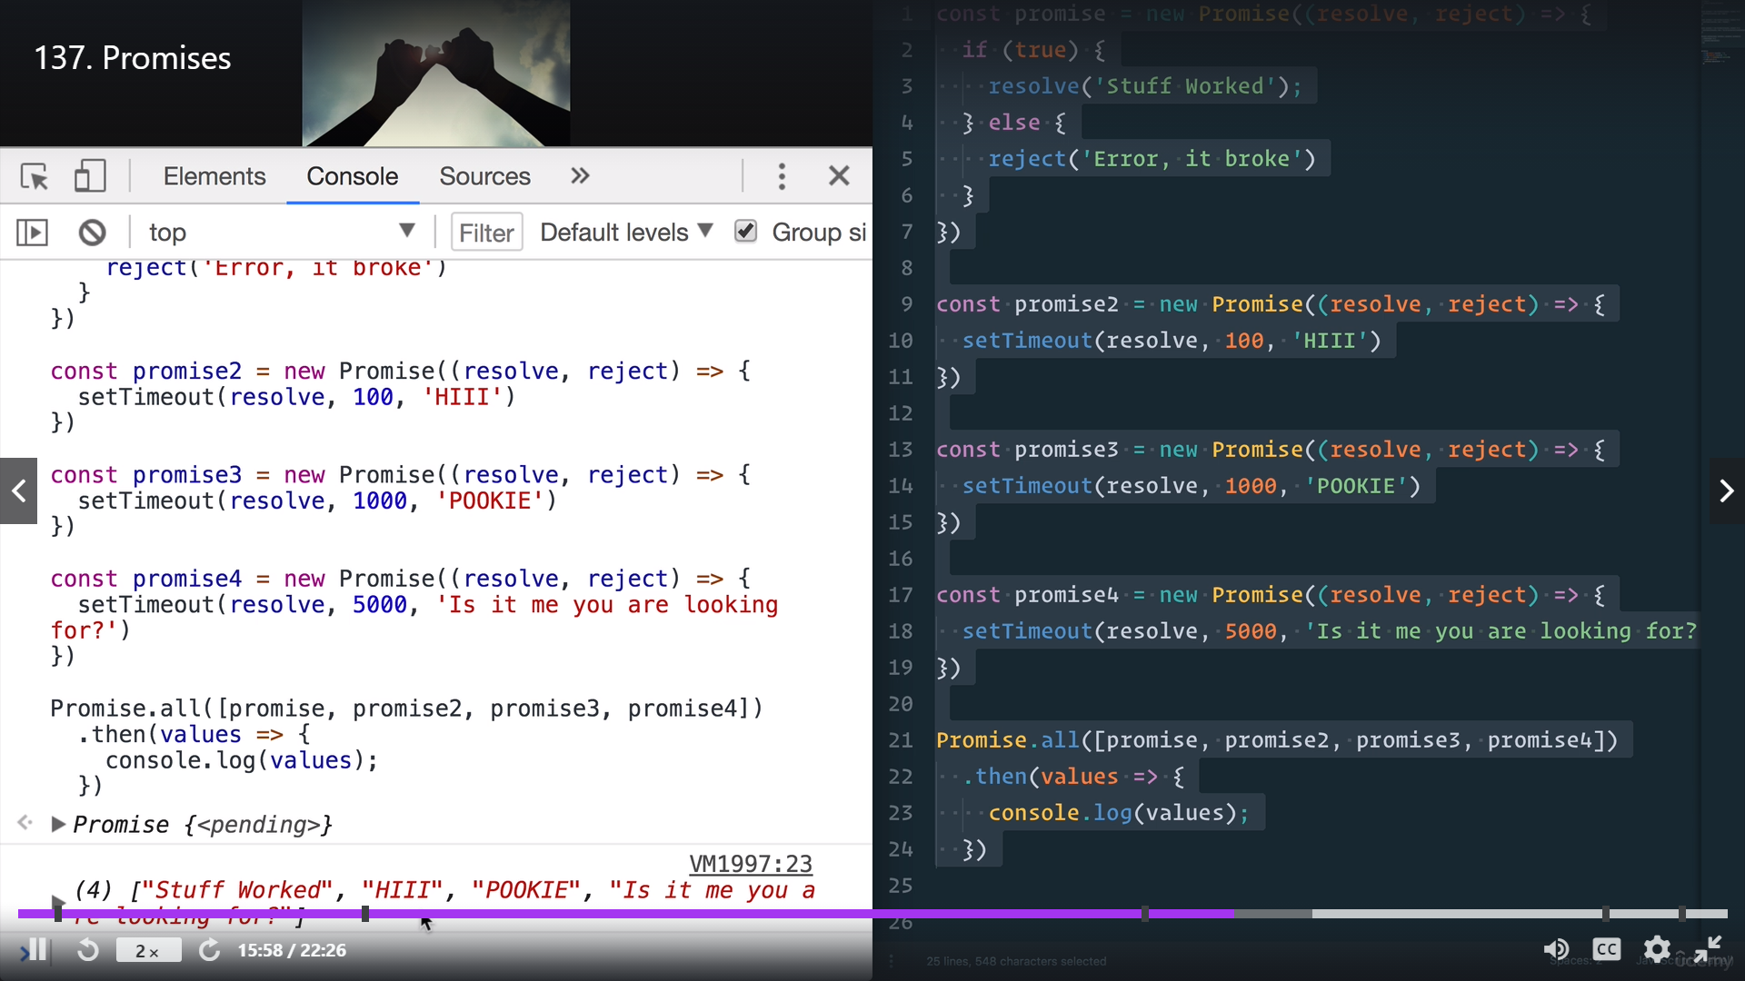

So, in the above example, the result will come after 5 seconds. Another example is shown below.

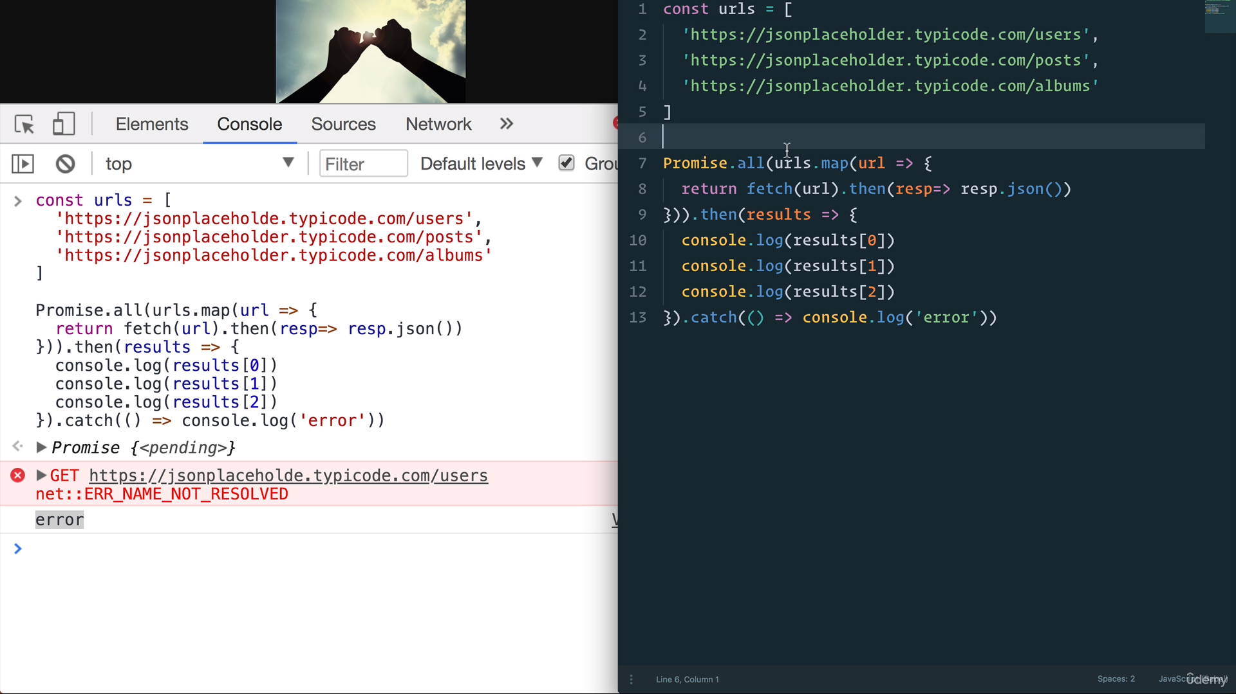

This is an API call example.

## Async Await

This is a new feature with ES8 JS.

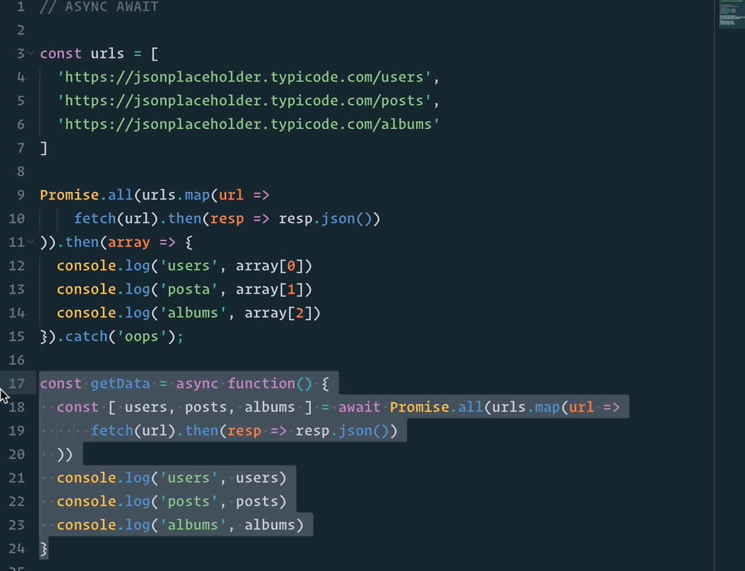

It is same as *.then()* and *.catch()* but is more readable also. Its main purpose is to make a asynchronous code to look synchronous.

## ES9 (ES2018)

Some new features have been included in the ES9 JS. The first one is object spread.

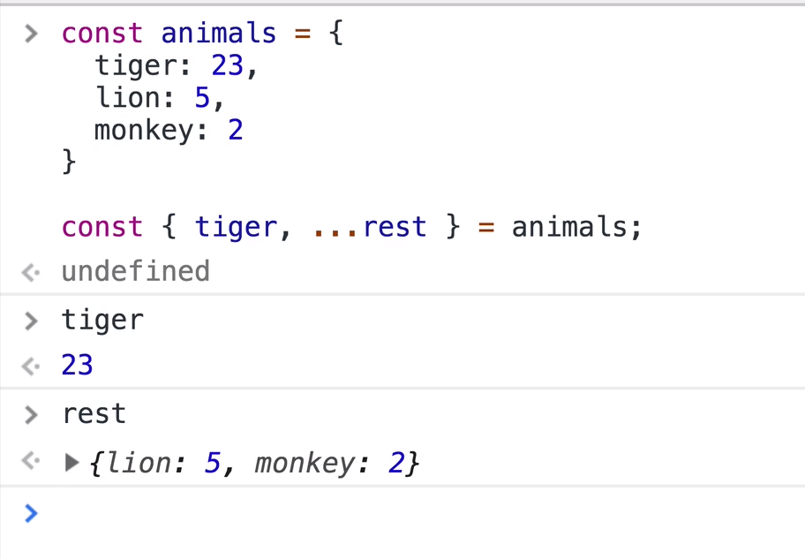

The next new thing is *.finally()* which is something that always executes once the promise is finished, even if there is an error that is caught.

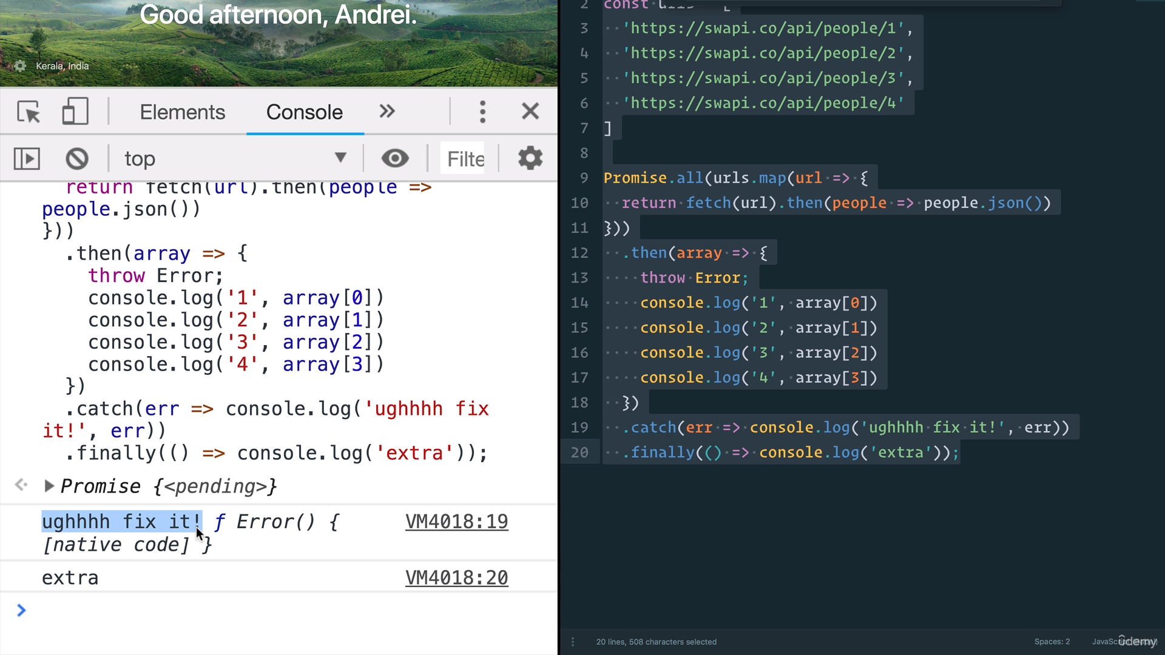

Another new feature is *for await of*.

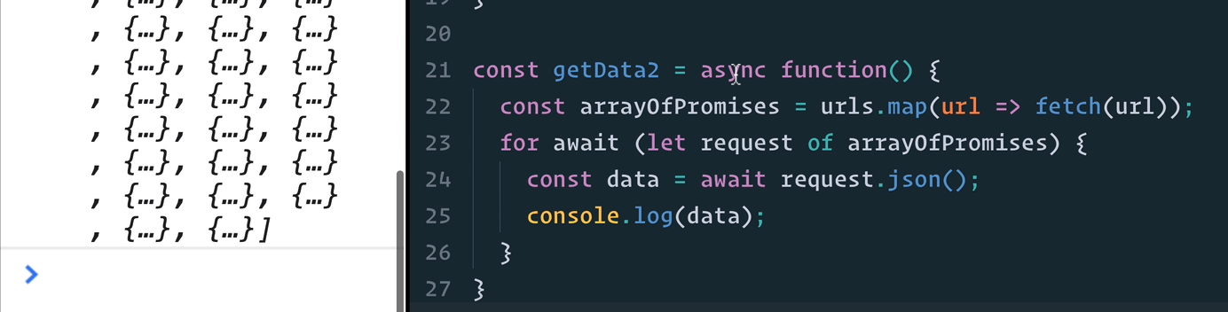

It allows us to use *await* with *for* loop.

## Job Queue

With the addition of new ES6 in JS, we got Promises. Promises were natively built and did not use Web API and so, they needed a separate callback queue (task queue). This is called the **job queue** also called **microtask queue**. Job queue has higher priority than callback queue. Let’s look at the example shown below.

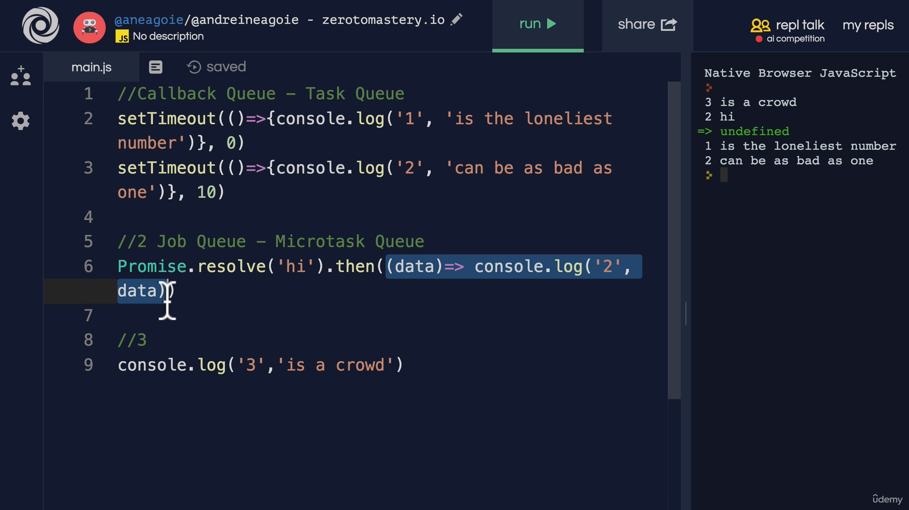

As expected, line 9 is got on the call stack first, then job queue is checked and because there is a promise involved, the Promise is resolved after line 9. Then set timeouts are executed in their respective orders.

So here is the updated architecture of JS engine.

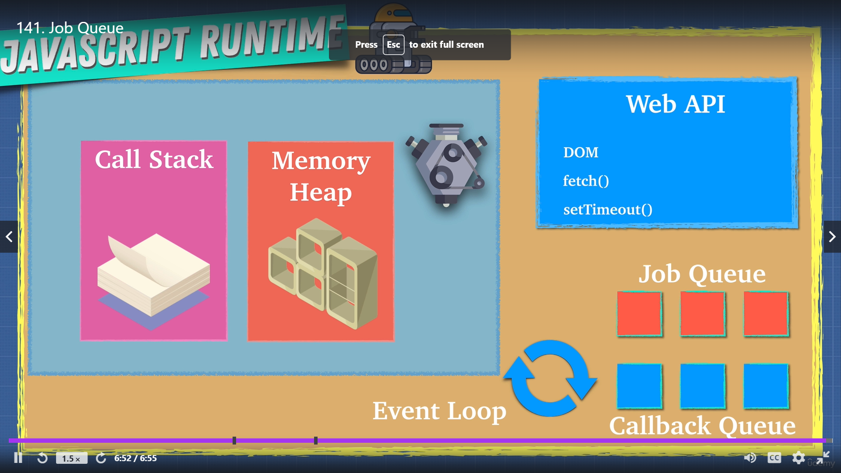

Notice that we now have a job queue.

## Race, Parallel and Sequence

There are three ways in which you can run promises. Let us analyze the code shown below for that.

const promisify = (item, delay) =>

new Promise((resolve) =>

setTimeout(() =>

resolve(item), delay));

const a = () => promisify('a', 100);

const b = () => promisify('b', 5000);

const c = () => promisify('c', 3000);

async function parallel() {

const promises = [a(), b(), c()];

const [output1, output2, output3] = await Promise.all(promises);

return `prallel is done: ${output1} ${output2} ${output3}`

}

async function race() {

const promises = [a(), b(), c()];

const output1 = await Promise.race(promises);

return `race is done: ${output1}`;

}

async function sequence() {

const output1 = await a();

const output2 = await b();

const output3 = await c();

return `sequence is done ${output1} ${output2} ${output3}`

}

sequence().then(console.log)

parallel().then(console.log)

race().then(console.log)

The function *parallel()* runs all the promises at the same time using *Promise.all()* function. So all the promises are run and the maximum time is taken and the output is displayed on the console.

The function *race()* on the other hand returns the output of the fastest promise and doesn’t care about others.

The function *sequence()* runs the code using *async-await* and returns the output in the time which is the sum of time taken by all the promises individually.

## *allSettled()*

The new add on in ES2020 in JS is *allSetlled()* method in the Promise class. *Promise.all()* expects that all promises should resolve and if even one of them fails, it will short-circuit the entire process. However, the *allSettled()* method does not break with this and instead returns an array of results, no matter if any one or more of them has been rejected.

## Threads, Concurrency, and Parallelism

JS is a single threaded language and therefore, it cannot do tasks in parallel. So, NodeJS came up with **worker threads** which can be used if your CPU is multi-core, where in you can initiate separate instances of node on these worker threads and they can run in parallel.

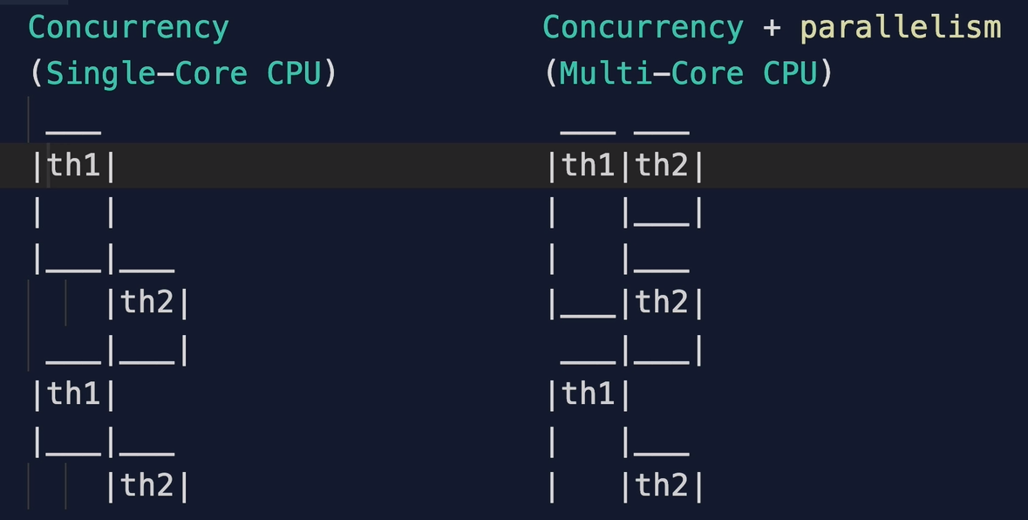

# Modules

Usually, variables in a scope cannot be used by objects or functions outside their scope. And without inter-operability, the whole purpose of writing code gets dissolved. One solution could be to use the global scope, however, it can lead to errors sometimes, if someone deliberately changes the variable name or type, isn’t it? Some functions using it could work, some might fail. This is called **tight coupling**. To overcome this, we use the **Module Pattern**.

## Module Pattern

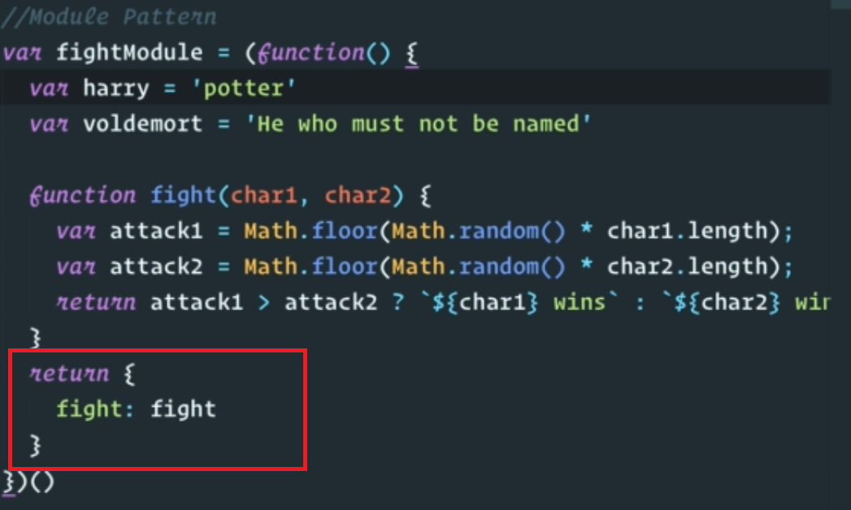

Use IIFEs to hide variables that you do not want to be accessed publicly, like **harry** and **Voldemort** but return those which you want to access outside, like **fight()** inside an object. Note that to access fight function, you now do **fightModule.fight()**. This is how module pattern works. Basically, we are using the Module scope. The scope hierarchy is **Global 🡪 Module 🡪 Function 🡪 Block (using let and const)**.

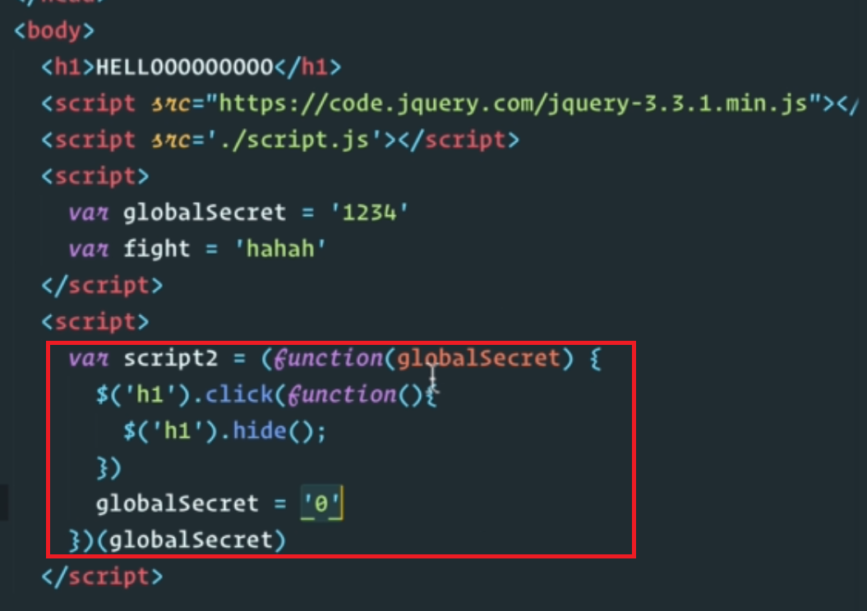

Note that **globalSecret** is a global variable, but if we define a function parameter (with the same name), we won’t be modifying the actual global variable inside IIFE. To import a global variable in this module, pass the global variable like this **(function() {// use global_variable here.})(global_variable).**

## Cons of Module Pattern

Module pattern is great and should be use whenever required. However, there are two main problems with it.

1. It does not completely resolve the problem of global variables overwriting. The **fightModule** variable above can still be overwritten.
2. 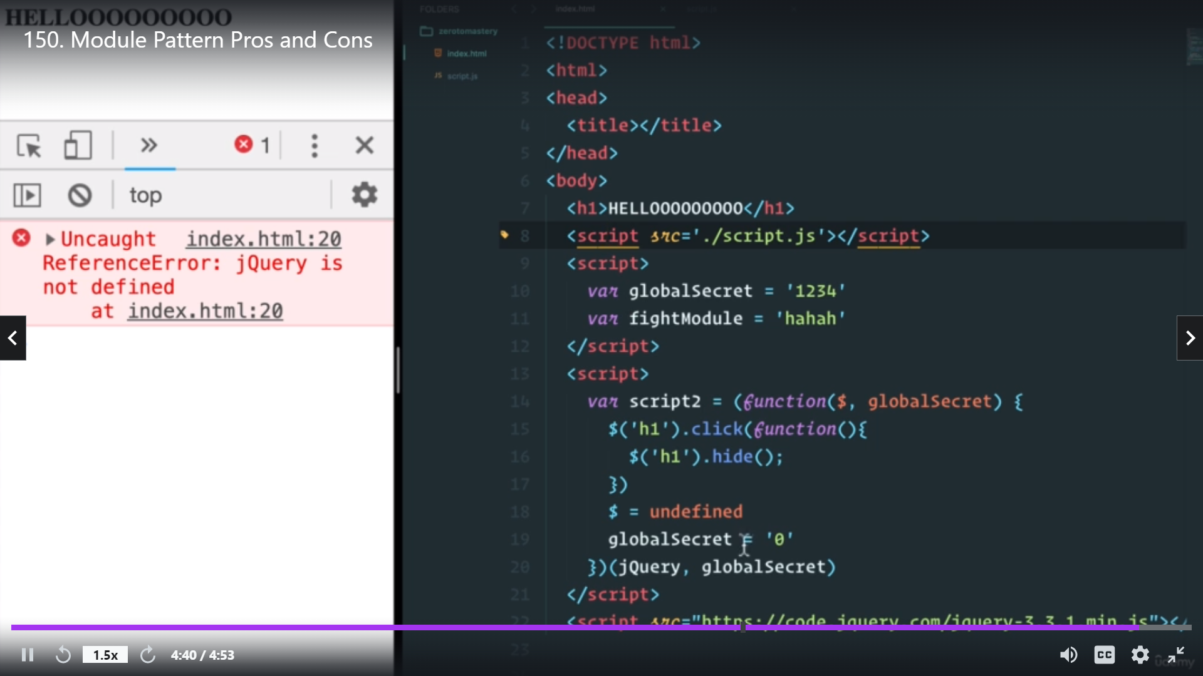 In this image, we see that if we don’t know the dependencies before hand, we can get errors. In the above image, jQuery is imported at the last, but is being used in IIFE.

## CommonJS and AMD

The problem of ordering the dependencies as discussed in the point 2 above can be solved by using CommonJS. CommonJS uses **require()** syntax to import modules and it internally takes care of the dependency ordering. Read more about CommonJS and AMD on [CommonJS - Wikipedia](https://en.wikipedia.org/wiki/CommonJS#:~:text=CommonJS%20is%20a%20project%20with,outside%20of%20the%20web%20browser.) and [Asynchronous module definition - Wikipedia](https://en.wikipedia.org/wiki/Asynchronous_module_definition) (AMD).

## ES6 Modules

Instead of using IIFEs, ES6 introduced the following syntax.

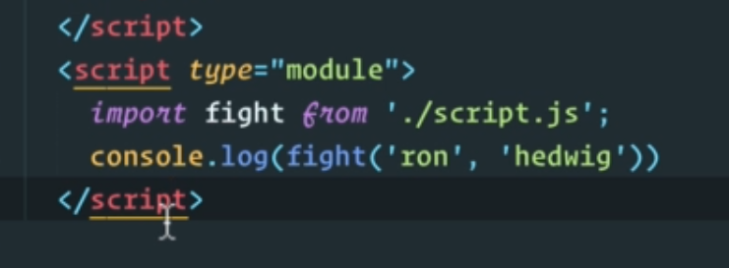

**Import** and **export** keywords can be used to share modules.

# Errors in JavaScript

Just like any other programming language, JavaScript too has error handling capabilities. The **Error()** class generates new errors. The *throw* keyword interrupts the flow of the program and throws an exception. We have many errors like syntax error, reference error, etc in JavaScript.

We use try-catch block to handle errors in JS. There is also a *finally* block which is executed once either of the try or catch blocks are executed; just like in Python. However, asynchronous errors like those caused by web APIs and setTimeouts are not handled properly. For these, we have asynchronous error handling.

For asynchronous error handling, we need to use the *.then()* and *.catch()* methods of the promises. Please note that *then* will work after *catch*, if needed. This is shown in the image below.

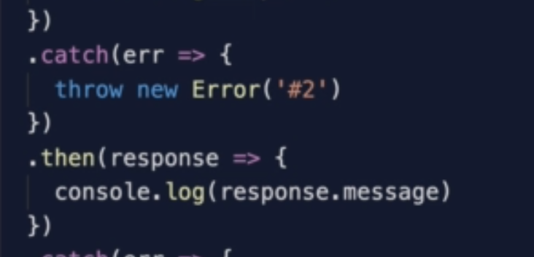

Here, *response.message* would be the error message. We can also handle asynchronous errors using simply try-catch if we use **async-await**.

